

**Mathematics @ South Marston CofE Primary School**

“Without mathematics, there’s nothing you can do. Everything around you is mathematics. Everything around you is numbers.” Shakuntala Devi

**Intent:**

*Why do we teach this? Why do we teach it the way we do?*

At South Marston, we understand that mathematics is crucial for each child's everyday life and future success. Mathematics helps children grasp relationships and patterns in numbers and space, which are essential for navigating the world around them. It plays a vital role in daily life, science, technology, engineering, and financial literacy, and is key to many career paths.

Our aim is to equip every child with the self-confidence and resilience needed to reach their full potential. We achieve this by ensuring that they develop fluency in calculation, logical reasoning, problem-solving skills, and abstract thinking.

We focus on nurturing confident, competent, and independent mathematicians. Our approach fosters a deep conceptual understanding of mathematics and its interconnected concepts, allowing children to apply their learning across various contexts. We also emphasise the importance of articulating, discussing, and explaining their thought processes using precise mathematical vocabulary.

Our 'mistake-friendly' classrooms encourage pupils to view errors as valuable learning opportunities, promoting a mind-set focused on thinking rather than merely performing tasks. This environment helps children grow into resilient, inquisitive learners, equipping them with the skills necessary to be lifelong mathematicians.

**Implementation:**

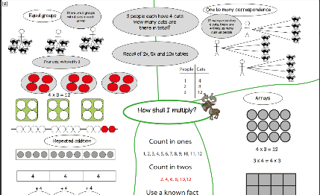*What do we teach? What does this look like?*

To enhance our mastery approach and ensure consistent, high-quality mathematics teaching, we have adopted the White Rose Mathematics framework, a widely-recognised scheme used in numerous educational settings. Although we utilise White Rose resources and teaching sequences, we trust our teachers to tailor lesson delivery based on their in-depth knowledge of their pupils.

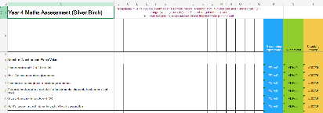We are committed to providing a coherent progression through the national curriculum. Each year group follows a medium-term plan that builds a solid foundation of mathematical understanding through small, incremental steps. Formative assessment is integral to each lesson and unit, enabling teachers to adapt their planning to meet the needs of their pupils effectively.

We emphasise the importance of a deep understanding of key mathematical concepts to ensure continuity as pupils’ advance through year groups. Accordingly, we may allocate additional time to the objectives outlined in the Department for Education's "Ready-to-Progress" criteria, developed in collaboration with the National Centre for Excellence in the Teaching of Mathematics.

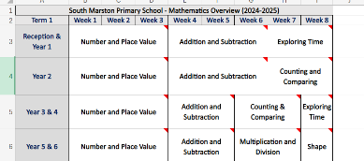Our approach places significant emphasis on the four operations (addition, subtraction, multiplication, and division). Teachers and pupils use South Marston’s calculation strategies, visual aids, and tools to support understanding and application of these operations.

Fluency, reasoning, and problem-solving are central to our mathematics curriculum. We regularly incorporate Practice It (for fluency), Twist It, and Solve It (for reasoning and problem-solving) lessons. Teachers foster mathematical discussion and questioning to deepen understanding and address misconceptions when pupils make errors. We ensure children have ample opportunities to prepare for assessments and tests.

In line with our mathematics non-negotiables, we provide ample opportunities for developing arithmetic and mental maths skills. Each math lesson begins with a short arithmetic starter, such as times table tests, Fluency in 5 questions, number bonds bingo, or number talk, aimed at improving retrieval practice and rapid recall.

In the Early Years Foundation Stage, staff design and facilitate a range of teacher-led and child-initiated math activities, guided by the National Centre for Excellence in the Teaching of Mathematics (NCETM) framework. This framework includes cardinality and counting, comparison, composition, pattern, shape and space, and measures. Evidence of children’s progress is documented in learning journals and through observations.

*View the Mathematics National Curriculum objectives here -* [*https://assets.publishing.service.gov.uk/media/5a7da548ed915d2ac884cb07/PRIMARY_national_curriculum_-_Mathematics_220714.pdf*](https://assets.publishing.service.gov.uk/media/5a7da548ed915d2ac884cb07/PRIMARY_national_curriculum_-_Mathematics_220714.pdf)

*Visit Times Table Rockstars here -* [*https://play.ttrockstars.com/auth*](https://play.ttrockstars.com/auth)

*Visit White Rose Maths here -* [*https://whiteroseeducation.com/resources*](https://whiteroseeducation.com/resources)

**Impact:**

*What will this look like?*

Children at South Marston are enthusiastic and happy learners who speak eagerly about their mathematics progress. The emphasis on 'mastery' and precise mathematical language use is evident in their class discussions and interactions. Our commitment to mastery has led to notable achievements in arithmetic, reflecting our pupils' stronger fluency in numbers. Consistent teaching practices, which are known to be effective for long-term pupil progress, are observed across the school.

Cross-school moderation demonstrates that all ability groups face high levels of challenge, with reasoning and problem-solving activities embedded throughout the curriculum. This approach ensures that teacher assessments of pupil learning depth are increasingly accurate.

As a result, we focus on high standards in mathematics, with end-of-Key Stage 2 (KS2) outcomes aligning with the national average. Furthermore, an increasing proportion of pupils are demonstrating greater depth at the end of each phase.

Pupils understand the real-world applications of mathematics and its relevance to various careers, recognising how mathematical skills can support their future potential. They apply these skills across different areas of the curriculum, with teachers providing diverse opportunities for maths use both inside and outside the classroom.

Teachers regularly assess and track pupil attainment and progress through a variety of methods, including end-of-unit tests, past and practice SATs papers, mental arithmetic activities, and work completed in exercise books. An assessment tracking grid is also used to monitor progress.

The Subject Leader plays a key role in enhancing the quality of mathematics teaching and learning. This includes conducting pupil voice sessions, learning walks, and reviewing samples of pupil work. The Subject Leader also supports staff development, arranges enrichment experiences, and oversees the delivery of mathematics education across the school.