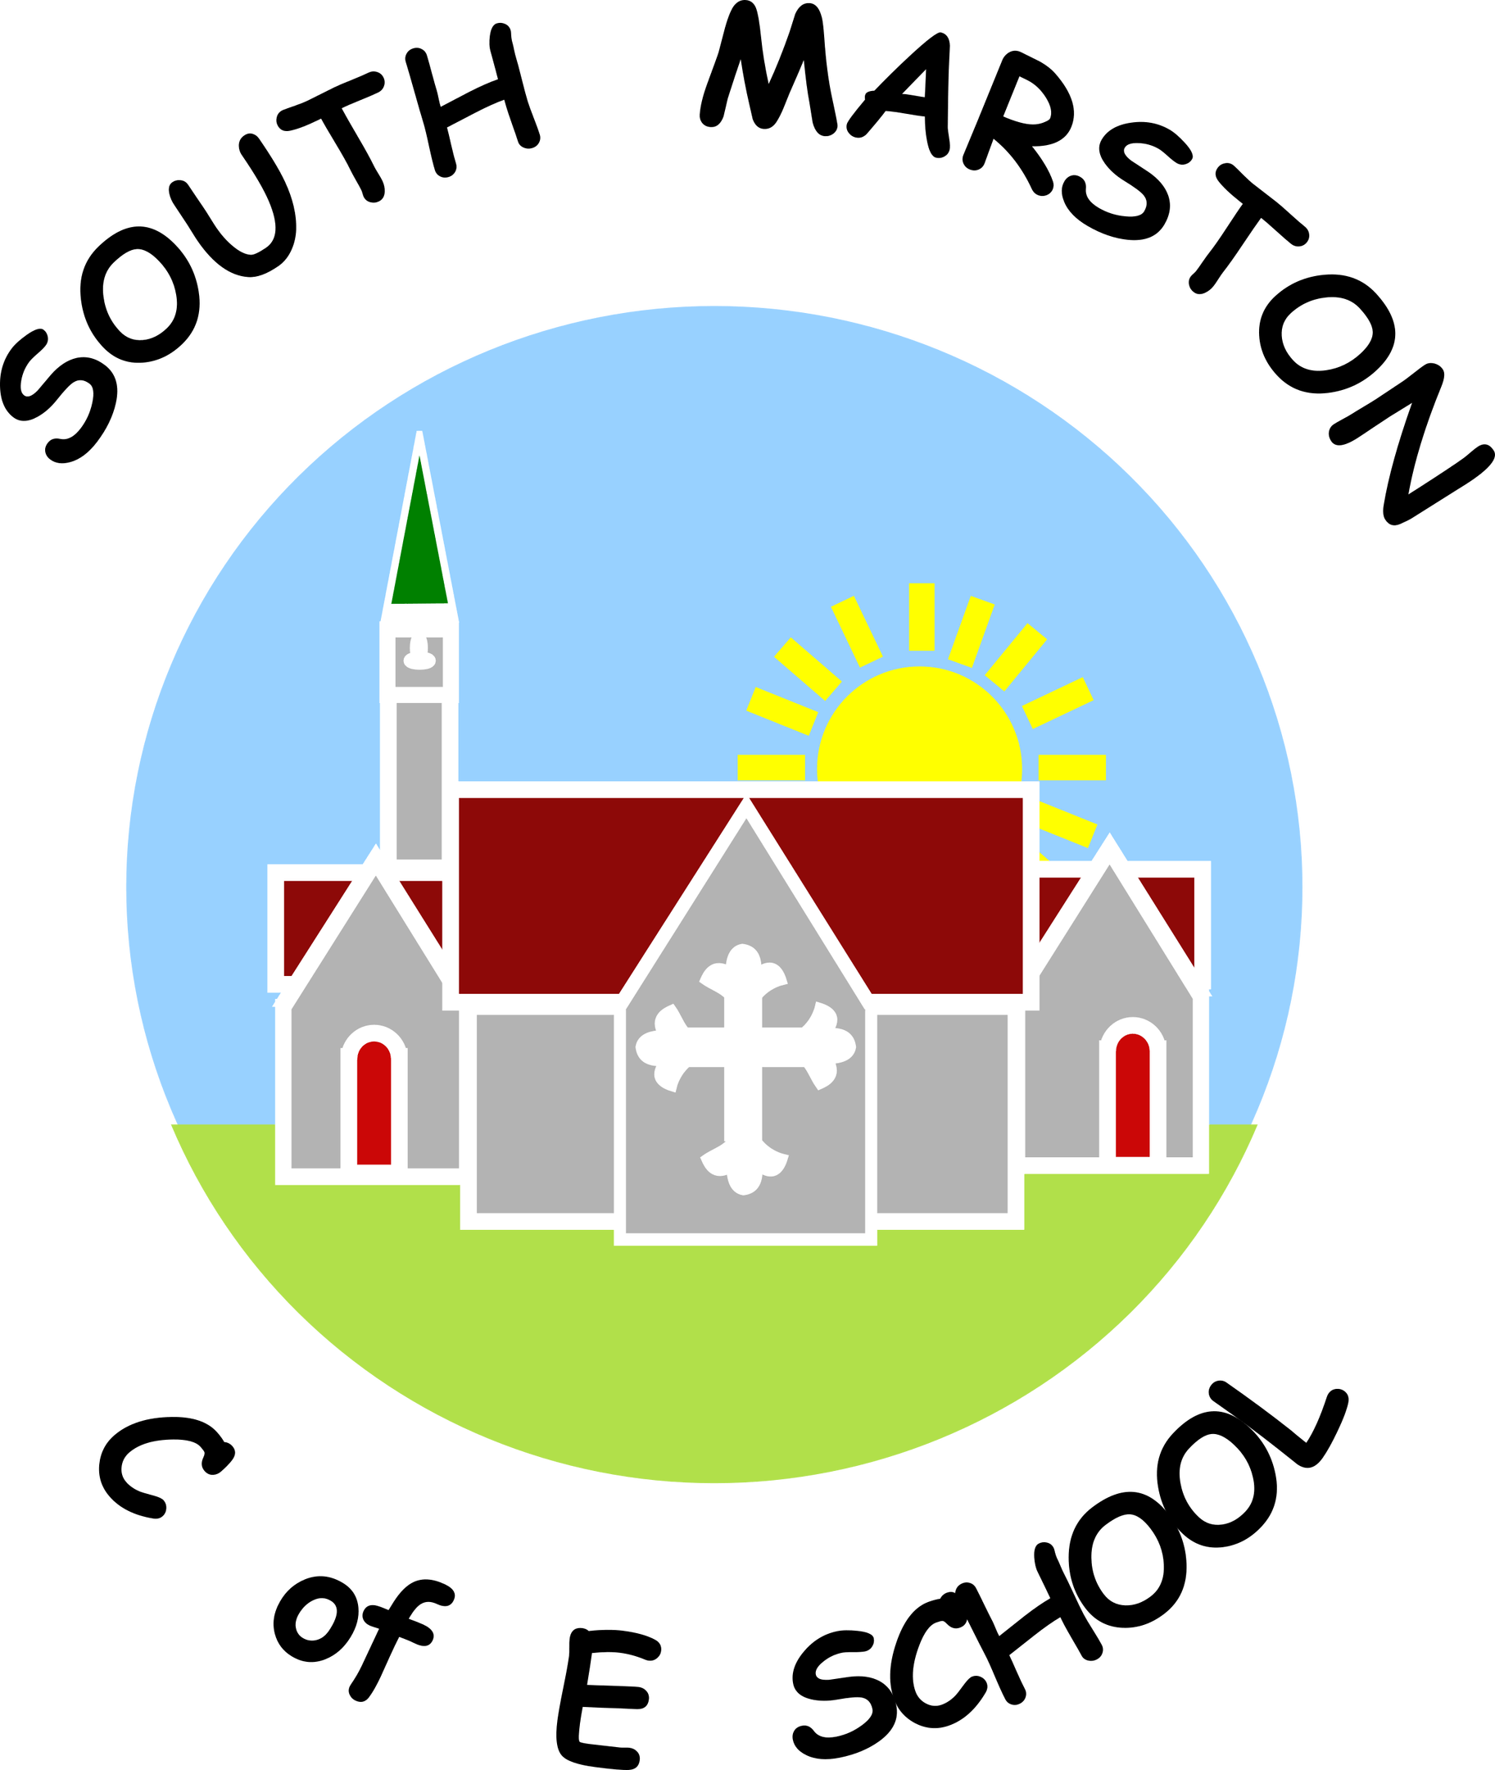

**English @ South Marston CofE Primary School**

“Reading is like breathing in, and writing is like breathing out.” Pam Allyn

**Intent:**

*Why do we teach this? Why do we teach it the way we do?*

At South Marston, our English curriculum is designed to ignite a passion for reading, writing, and discussion in every child. We prioritise developing children’s comprehension skills and fostering a culture of pride in their writing. Our aim is for pupils to write with clarity and accuracy, adapting their language and style to various contexts.

We are committed to cultivating confidence in speaking and listening, encouraging children to use discussion as a tool for learning and communication. We believe that a robust foundation in literacy is essential for a high-quality education and for enabling pupils to engage fully in society.

Our literacy curriculum follows a clear progression pathway, ensuring that each child builds on their knowledge and skills as they advance through the primary years. Literacy is seamlessly integrated into all lessons, and we are dedicated to achieving a high standard of English for all our pupils.

**Implementation:**

*What do we teach? What does this look like?*

At South Marston, we have developed a rigorous and well-organised English curriculum that provides numerous purposeful opportunities for reading, writing, and discussion. Our approach is underpinned by a diverse selection of high-quality texts and resources designed to motivate and inspire pupils. Teachers ensure that cross-curricular links are seamlessly integrated into the 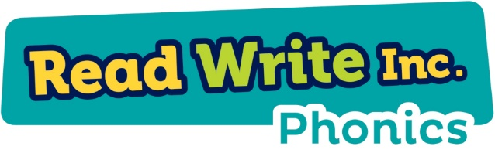programme of study, with a clear yearly overview detailing the texts to be used for teaching writing skills each half term. This overview includes fiction, non-fiction, and poetry, and specifies the expected written outcomes and their intended purposes.

In the Early Years Foundation Stage and Key Stage 1, our daily phonics and reading lessons are based on the validated Read, Write, Inc. scheme. Children are grouped by ability and assessed each term to ensure appropriate support and progression. These sessions focus on 'speed sounds' and accurate, paced reading. Staff receive ongoing training and support from specialist advisors to enhance their effectiveness in teaching phonics a nd reading. Home reading books are matched to each child's phonics level, and we work closely with families to prepare pupils for the Year 1 Phonics Screening Check.

In Key Stage 2, pupils engage with a variety of texts and genres through group, paired, and whole-class reading activities. Instruction focuses on VIPERS skills (Vocabulary, Inference, Prediction, Explanation, Retrieval, and Sequencing/Summarising) to help pupils become fluent, expressive, and engaged readers with strong comprehension abilities. We encourage home reading, with pupils logging their progress on our electronic platform, Boom Reader. Our school promotes a love of reading through diverse book choices, visits to our newly renovated library, and reading buddy systems.

Speaking and listening skills are integrated throughout our curriculum, encompassing activities such as presentations, role play, drama games, discussions, debates, and script work.

In writing lessons, we follow a 2-3 week cycle using the Integra English guidance, ensuring pupils develop a thorough understanding of the text studied and its features before applying these skills in their own writing. The cycle includes shared and modelled writing, spelling, punctuation, and grammar exercises, independent writing, and editing activities. Pupils share ideas during modelled writing and through their independent work. Teachers deliver grammar and punctuation instruction as outlined in the National Curriculum, both explicitly in weekly lessons and in the context of purposeful writing.

We use 'road maps' and 'writing journeys' to help pupils understand the progression of their writing skills and concepts throughout the term. Additionally, daily short spelling, punctuation, and grammar lessons reinforce the importance of correct terminology, punctuation, and spelling patterns.

Editing and revising are crucial components of our English process. Pupils use purple pens to correct grammatical, punctuation, and spelling errors, enhancing clarity and flow in their work.

In the Early Years Foundation Stage, English activities are aligned with the Literacy Early Learning Goals and include phonics games, fine motor skills exercises, rhymes and stories, phonics sessions, small world resources, role play, short writing tasks, and story sequencing.

*View the English National Curriculum objectives here -* [*https://assets.publishing.service.gov.uk/media/5a7de93840f0b62305b7f8ee/PRIMARY_national_curriculum_-_English_220714.pdf*](https://assets.publishing.service.gov.uk/media/5a7de93840f0b62305b7f8ee/PRIMARY_national_curriculum_-_English_220714.pdf)

*View the Read, Write, Inc. Phonics scheme here -* [*https://www.ruthmiskin.com/programmes/phonics/*](https://www.ruthmiskin.com/programmes/phonics/)

As a small school with mixed-age classes, we carefully consider each child's existing knowledge to build effectively on their prior learning. To ensure comprehensive coverage of skills, content, and knowledge, we operate a two-year cycle (Cycle A and Cycle B). This approach allows pupils to revisit and consolidate prior learning.

**Impact:**

*What will this look like?*

The impact of our English curriculum is evident in the clear progress, sustained learning, and transferable skills our children demonstrate. With the writing journey effectively established and thoroughly implemented across both Key Stages, pupils are growing into confident writers. By the time they reach upper Key Stage 2, they are familiar with most writing genres, allowing us to focus on enhancing creativity, writer’s craft, and the sophisticated use of grammar and punctuation.

To accurately assess and monitor children’s progress in English, teachers utilise a variety of tools and methods, including phonics assessments, reading and SPAG SATs tests, spelling tests, observations, and analysis of work in pupils' exercise books. We have also introduced a tracking assessment grid to continuously analyse and track student progress. We regularly host and attend moderation events with other schools to track progress, discuss outcomes and monitor the quality of work.

Termly assessments reveal that most pupils at South Marston are meeting age-related expectations in Literacy. We consistently have pupils achieving at a greater depth in reading and writing by the end of Key Stage 1, and we are dedicated to achieving similar outcomes by the end of Key Stage 2. We anticipate that our new literacy initiatives will further enhance pupils' learning and progress.

English is integrated throughout our curriculum, resulting in improved cross-curricular writing standards. Skills learned in English lessons are effectively transferred to other subjects, demonstrating the consolidation of skills and a deeper understanding of grammar and punctuation in various contexts.

As pupils transition from South Marston to their future educational pursuits, we hope they carry with them their creativity, passion for English, and high aspirations, continuing to develop and thrive in their ongoing learning journeys.

The Subject Leader plays a key role in monitoring and enhancing the quality of teaching and learning in English. This includes conducting pupil voice sessions, learning walks, and reviewing samples of pupil work. The Subject Leader also provides updates and professional development for the staff team, arranges English related experiences, and reviews the delivery of English education across the school.