

**Science @ South Marston CofE Primary School**

“Science is magic that works.” - Kurt Vonnegut

**Intent:**

*Why do we teach this? Why do we teach it the way we do?*

At South Marston, we place significant emphasis on the importance of science and scientific enquiry. Our science curriculum is designed to be fun, practical, and engaging, with the aim of inspiring the next generation to excel in the subject. We adhere closely to the national curriculum, fostering a strong curiosity and interest in scientific concepts.

Central to our approach is scientific investigation. We strive to deliver lessons that involve varied and systematic investigations, equipping pupils with the skills to ask and answer scientific questions about the world around them. Science at our school is seen as encompassing the acquisition of knowledge, concepts, skills, and positive attitudes.

Throughout their time at South Marston, children develop key scientific knowledge and skills as outlined in each unit and year group. Our curriculum ensures that 'Working Scientifically' skills are continuously built upon, allowing pupils to confidently use equipment, conduct experiments, and construct and explain scientific arguments. They become familiar with scientific terminology and maintain a strong sense of curiosity, constantly questioning and exploring their surroundings.

**Implementation:**

*What do we teach? What does this look like?*

At South Marston, the acquisition of key scientific knowledge is central to our science curriculum. We utilise linked knowledge organisers to help pupils learn and retain crucial vocabulary and concepts for each unit. The progression of skills for working scientifically is carefully developed across year groups, with a strong emphasis on scientific enquiry within our lessons.

Our teachers foster a positive attitude towards science and maintain high expectations for all pupils to achieve excellence in the subject. To support the development of skills and knowledge, we implement the Developing Experts scheme of work. This scheme provides pupils with exposure to scientific vocabulary and enquiry-based learning discussions. However, teachers are encouraged to use their professional judgment to adapt lessons and activities to ensure comprehensive coverage and enjoyment.

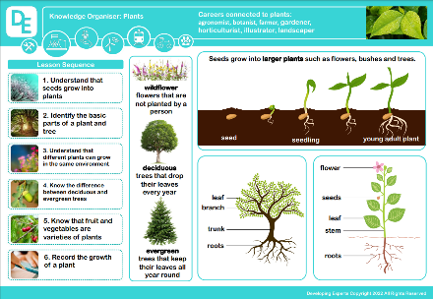Each pupil has a science book where they document their learning and evidence of their work. Working Scientifically skills are integrated into lessons to ensure continuous development throughout the pupils' school careers. New vocabulary and challenging concepts are introduced through direct teaching, with a focus on hands-on experience. Teachers model the use of scientific equipment and various enquiry skills to reinforce scientific understanding.

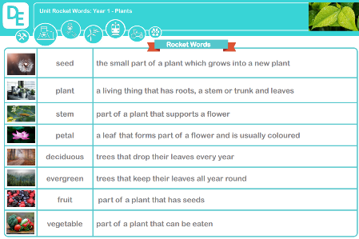To enhance learning, teachers create opportunities for outdoor experiences and workshops with experts. Enrichment days, such as 'Science Week', are used to elevate the profile of science and provide pupils with time to explore scientific topics freely.

In the Early Years Foundation Stage (EYFS), science and understanding the world are integral to our curriculum. Science is introduced through engaging activities that encourage children to explore, problem-solve, observe, predict, think critically, and discuss their observations about the world around them. Activities such as exploring the forest, learning about the seasons, and investigating materials that floa t or sink are designed to connect with the Early Learning Goal of Understanding the World. These hands-on experiences help to build a strong foundation in scientific inquiry and foster a natural curiosity about the environment.

*View the Science National Curriculum here -* [*https://assets.publishing.service.gov.uk/media/5a806ebd40f0b62305b8b1fa/PRIMARY_national_curriculum_-_Science.pdf*](https://assets.publishing.service.gov.uk/media/5a806ebd40f0b62305b8b1fa/PRIMARY_national_curriculum_-_Science.pdf)

*View the Developing Experts scheme here -* [*https://www.developingexperts.com/*](https://www.developingexperts.com/)

As a small school with mixed-age classes, we adapt our teaching to build on each child’s prior knowledge effectively, operating on a two-year cycle (Cycle A and Cycle B) to ensure thorough coverage and reinforcement of skills and knowledge.

CYCLE A

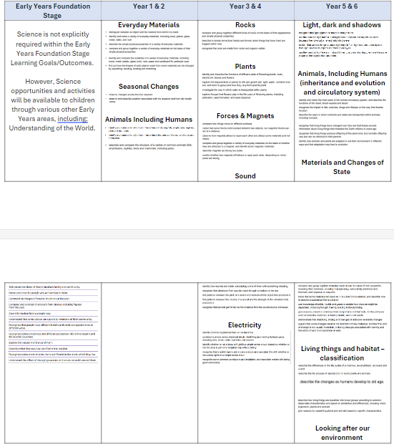

CYCLE B

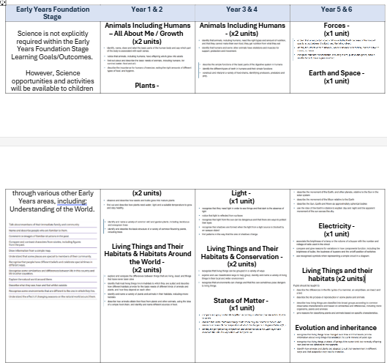

**Impact:**

*What will this look like?*

At South Marston, our approach to teaching science ensures that pupils experience a fun and engaging science education, laying a strong foundation for understanding the world as they progress beyond primary school. We use a blend of formal assessment strategies, such as periodic year group tasks and quizzes, alongside informal methods, including concept maps, verbal and written reflections, and presentations. This combination allows us to gauge pupil understanding effectively.

Formative assessment is central to our evaluation of science education, as it enables us to promptly address misconceptions and close knowledge gaps, preventing the build-up of insecure scientific understanding. Through this approach, pupils develop a genuine interest in science, retain knowledge with real-life relevance, and learn to question ideas and reflect on their knowledge.

Pupils are encouraged to articulate their understanding of scientific concepts, reason scientifically with precise language, and demonstrate strong mathematical skills in organising, recording, and interpreting results. Collaborative and practical work is emphasised, helping pupils investigate and experiment effectively. Overall, our science curriculum at South Marston not only makes science exciting and enjoyable, but also equips pupils with the skills and knowledge they need to carry forward into their future studies and everyday lives.

The Subject Leader plays a crucial role in monitoring and enhancing the quality of Science teaching and learning. This involves conducting pupil voice sessions, learning walks, and reviewing samples of pupils' work. The Subject Leader also provides updates and professional development for staff, arranges Science experiences, and oversees the delivery of Science education throughout the school.