

**History @ South Marston CofE Primary School**

“History gives answers only to those who know how to ask questions.” Hajo Holborn

**Intent:**

*Why do we teach this? Why do we teach it the way we do?*

At South Marston, we foster a deep appreciation and understanding of history by guiding pupils in evaluating a range of primary and secondary sources. Our pupils will learn to articulate how these sources provide insights into how people lived in the past and how interpretations of history can vary. We encourage pupils to make connections between different historical periods and contexts, with the aim of cultivating engaged, motivated, and curious learners who can reflect on the past and relate it to the present.

Our History curriculum is meticulously designed to encompass all the skills, knowledge, and understanding outlined in the National Curriculum. According to the National Curriculum, a high-quality history education should enable pupils to gain a coherent understanding of Britain’s past and that of the wider world, while inspiring curiosity about historical events.

To ensure that pupils build secure knowledge and engage with a broad range of content, our History curriculum is organised into a long-term overview with detailed units. This structure allows for the careful planning of content knowledge, vocabulary, and skills at a more detailed level in the medium-term plans. History is taught through thematic blocks, and we make meaningful links with other subjects to enhance pupils' connections and understanding.

The History units are crafted to help pupils appreciate their own identity and comprehend the challenges of their time. Through this approach, pupils gain insights into the process of change over time and significant historical developments.

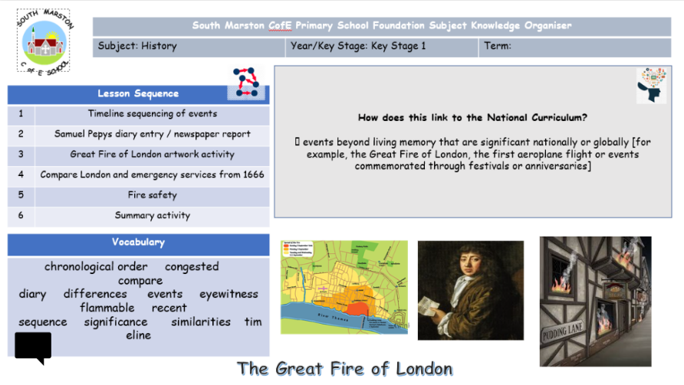**Implementation:**

*What do we teach? What does this look like?*

Our curriculum at South Marston is guided by our school vision, which is dedicated to helping every child—regardless of background, ability, or additional needs—flourish and become the best version of themselves.

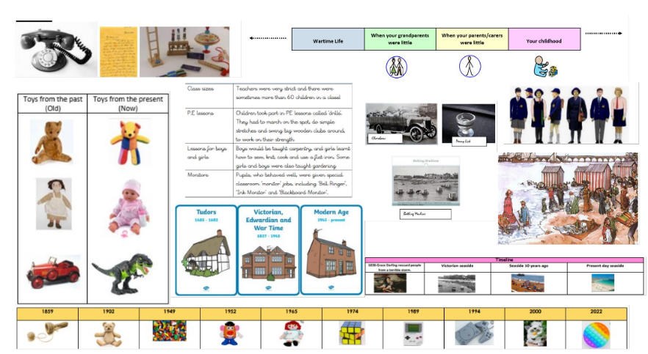We deliver the National Curriculum with a focus on clear progression in skills and knowledge. This approach ensures that learning builds year on year, with content sequenced to maximise educational outcomes for all pupils. In history, we are committed to developing pupils' skills as historians, enabling them to gather evidence, analyse it, and draw their own conclusions. Pupils learn to research and interpret primary and secondary sources, developing skills that will benefit them throughout their lives.

To enrich the curriculum, we offer a range of experiences, including educational visits, trips, and workshops relevant to each year group's topics. These opportunities provide hands-on learning, access to heritage sites, and interactions with expert historians.

Support for learning is enhanced through knowledge organisers, which help pupils retain new facts and vocabulary in their long-term memory. Assessment in history is ongoing, integrated into cross-curricular themes to inform lesson planning and differentiation. Summative assessments are conducted at the end of each topic, using an objective tracker to identify areas for school improvement and further development.

We strive to offer our historians diverse and memorable experiences both inside and outside the classroom, creating opportunities that deepen their understanding and support their educational journey.

Find the History National Curriculum objectives here- <https://assets.publishing.service.gov.uk/media/5a7c2917e5274a1f5cc762cf/PRIMARY_national_curriculum_-_History.pdf>

CYCLE A

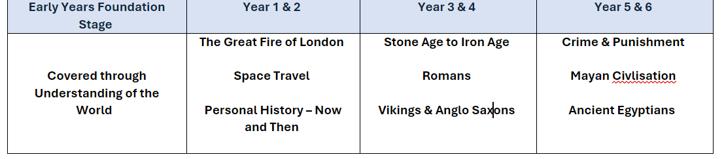

CYCLE B

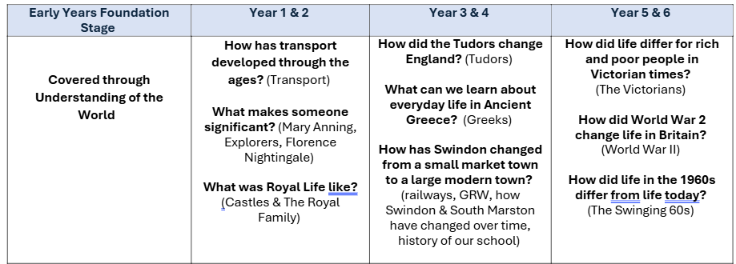

**Impact:**

*What will this look like?*

By the time pupils leave South Marston, they will have developed a comprehensive understanding of key people, events, and contexts from the historical periods studied. They will be adept at thinking critically about history, communicating their ideas confidently to various audiences, and consistently using detailed, accurate historical evidence from diverse sources to support, evaluate, and challenge both their own views and those of others.

Our pupils will have honed their skills in reflecting, debating, discussing, and evaluating historical events, developing and refining questions and lines of enquiry. They will exhibit a strong passion for history, demonstrating enthusiasm and curiosity about the past and an understanding of the different ways people interpret historical events.

Pupils will show respect for historical evidence and use it robustly and critically to support their explanations and judgments. They will also be eager to embrace challenging tasks, including engaging in high-quality research across a variety of topics.

The Subject Leader is instrumental in enhancing the quality of History education. This role involves conducting pupil voice sessions, performing learning walks, and reviewing samples of pupils' work. The Subject Leader also provides staff with updates and professional development, organises enriching educational experiences, and ensures the effective implementation of the History curriculum across the school.