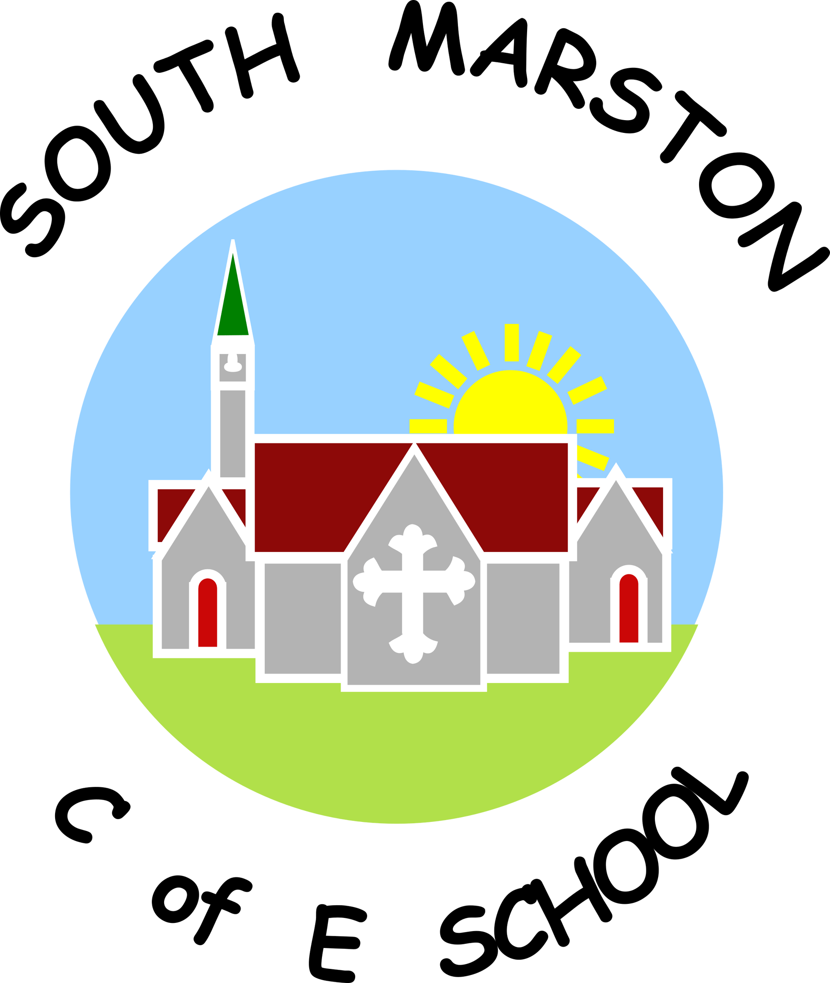

**Geography @ South Marston CofE Primary School**

“It's about understanding the complexity of our world, appreciating the diversity of cultures that exists across continents.” Barack Obama

**Intent:**

*Why do we teach this? Why do we teach it the way we do?*

Geography is fundamental to understanding our world, providing insights into both its natural and human dimensions. At South Marston, we are committed to helping children deepen their understanding of the world and their role within it. Our geography curriculum is designed to build knowledge and skills that extend beyond the subject, fostering investigative abilities and a comprehensive grasp of key geographical concepts.

We aim to ignite curiosity and fascination in our pupils about diverse places, people, and environments. By exploring natural and human processes, our goal is to cultivate a profound appreciation of the Earth's physical and human systems. We strive to expand geographical vocabulary, enhance knowledge of the wider world, and inspire high aspirations in our pupils.

Our approach to teaching geography is designed to instil a lifelong interest in the subject. Through studying various environments and processes, we aim to evoke a sense of awe and wonder about the world. Our curriculum supports pupils in developing the specific language needed to describe, question, and discuss geographical concepts, and encourages them to use their voices confidently in debates on relevant issues, such as deforestation or renewable energy.

We are dedicated to producing well-rounded individuals by offering opportunities to broaden their cultural capital and world experiences. Through our geography curriculum, we seek to prepare pupils not only to understand their place in the world but to engage thoughtfully with it.

**Implementation:**

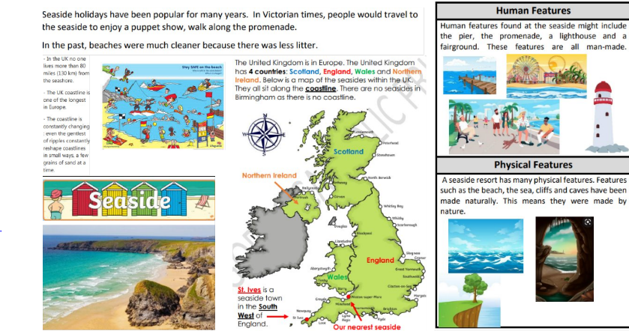*What do we teach? What does this look like?*

Aligned with the National Curriculum and tailored to the needs of our pupils, we have developed a comprehensive Geography overview that outlines the units and topics for each year group. Geography is incorporated into our two-year cycle, alternating with History to ensure a balanced and thorough coverage of the humanities. We also create connections between these subjects to reinforce and enrich the learning experience.

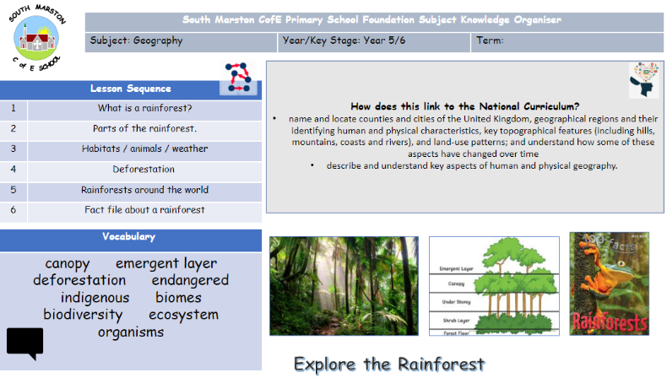Each lesson is designed to be age-appropriate and differentiated to meet individual needs, ensuring high expectations are consistently upheld. Pupils record their learning in geography books, which helps them consolidate their knowledge and reflect on their understanding at the end of each unit or lesson. Writing in Geography serves as a means for pupils to demonstrate their learning and deepen their knowledge.

Our whole-school focus on oracy supports a vocabulary-rich Geography curriculum. Teachers actively use questioning, facilitate discussions, and provide investigative opportunities to enhance vocabulary development. Key geographical knowledge and terminology, such as the names and locations of continents, countries, capital cities, and oceans, are regularly revisited to ensure retention and relevance.

We enrich learning through trips and activities designed to inspire and expand pupils' cultural experiences. These include local area walks, geography-themed days, and visits that link to specific geography units. Teachers are also encouraged to use diverse resources, such as videos, photographs, and newspaper articles, to create immersive learning experiences.

From Year 1 onwards, pupils have access to a knowledge organiser that details the sequence of learning, key content, and vocabulary. This document is used in their books and throughout geography lessons to support their understanding.

In the Early Years Foundation Stage (EYFS), children engage in geography-based learning through both adult-led and child-initiated activities, linking to the Understanding the World early learning goal. This includes exploring maps and globes, local walks, discussing holidays, creating simple maps, and learning about global animals and environments.

Please refer to the Geography Objectives here: <https://assets.publishing.service.gov.uk/media/5a7c1ecae5274a1f5cc75e97/PRIMARY_national_curriculum_-_Geography.pdf>

As a small school with mixed-age classes, we adapt our teaching to build on each child’s prior knowledge effectively, operating on a two-year cycle (Cycle A and Cycle B) to ensure thorough coverage and reinforcement of skills and knowledge.

CYCLE A

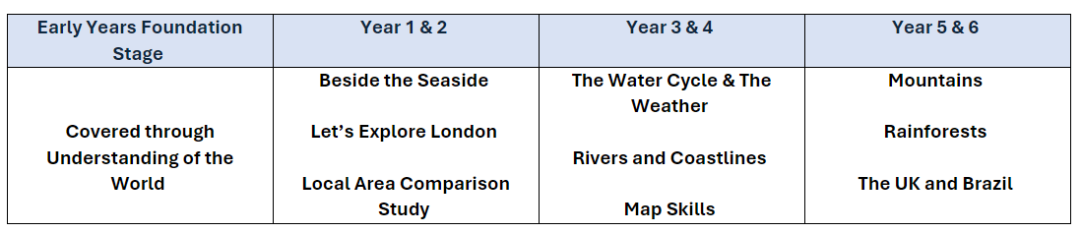

CYCLE B

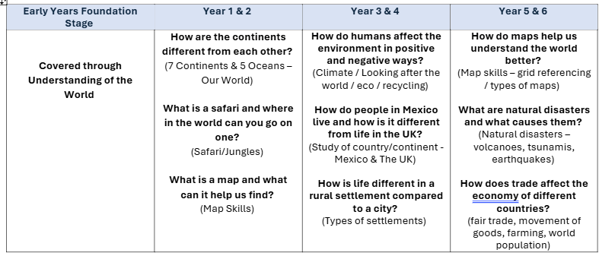

**Impact:**

*What will this look like?*

By the time pupils leave South Marston, they will possess a thorough understanding of the locations and characteristics of various places. They will have developed an extensive base of geographical knowledge and vocabulary, enabling them to engage fluently in complex geographical enquiry. Pupils will be adept at applying questioning skills and utilising effective analytical and presentation techniques to reach clear conclusions and construct reasoned arguments.

Their geographical work will reflect significant levels of originality, imagination, and creativity in interpreting and representing subject matter. They will have developed and frequently employed fieldwork skills and other geographical techniques. A deep passion for the subject and a genuine curiosity about the world and its people will be evident, alongside their ability to express well-balanced opinions on current and contemporary issues in society and the environment, grounded in strong knowledge and understanding.

As they advance through the school, pupils gain a profound understanding and appreciation of their local area within a wider geographical context, enriched further by regular school trips that provide contextual learning experiences.

The Subject Leader plays a critical role in enhancing the quality of Geography education. This includes conducting pupil voice sessions, performing learning walks, and reviewing samples of pupils' work. The Subject Leader also supports staff through updates and professional development, organises enriching experiences, and oversees the effective implementation of the Geography curriculum throughout the school.