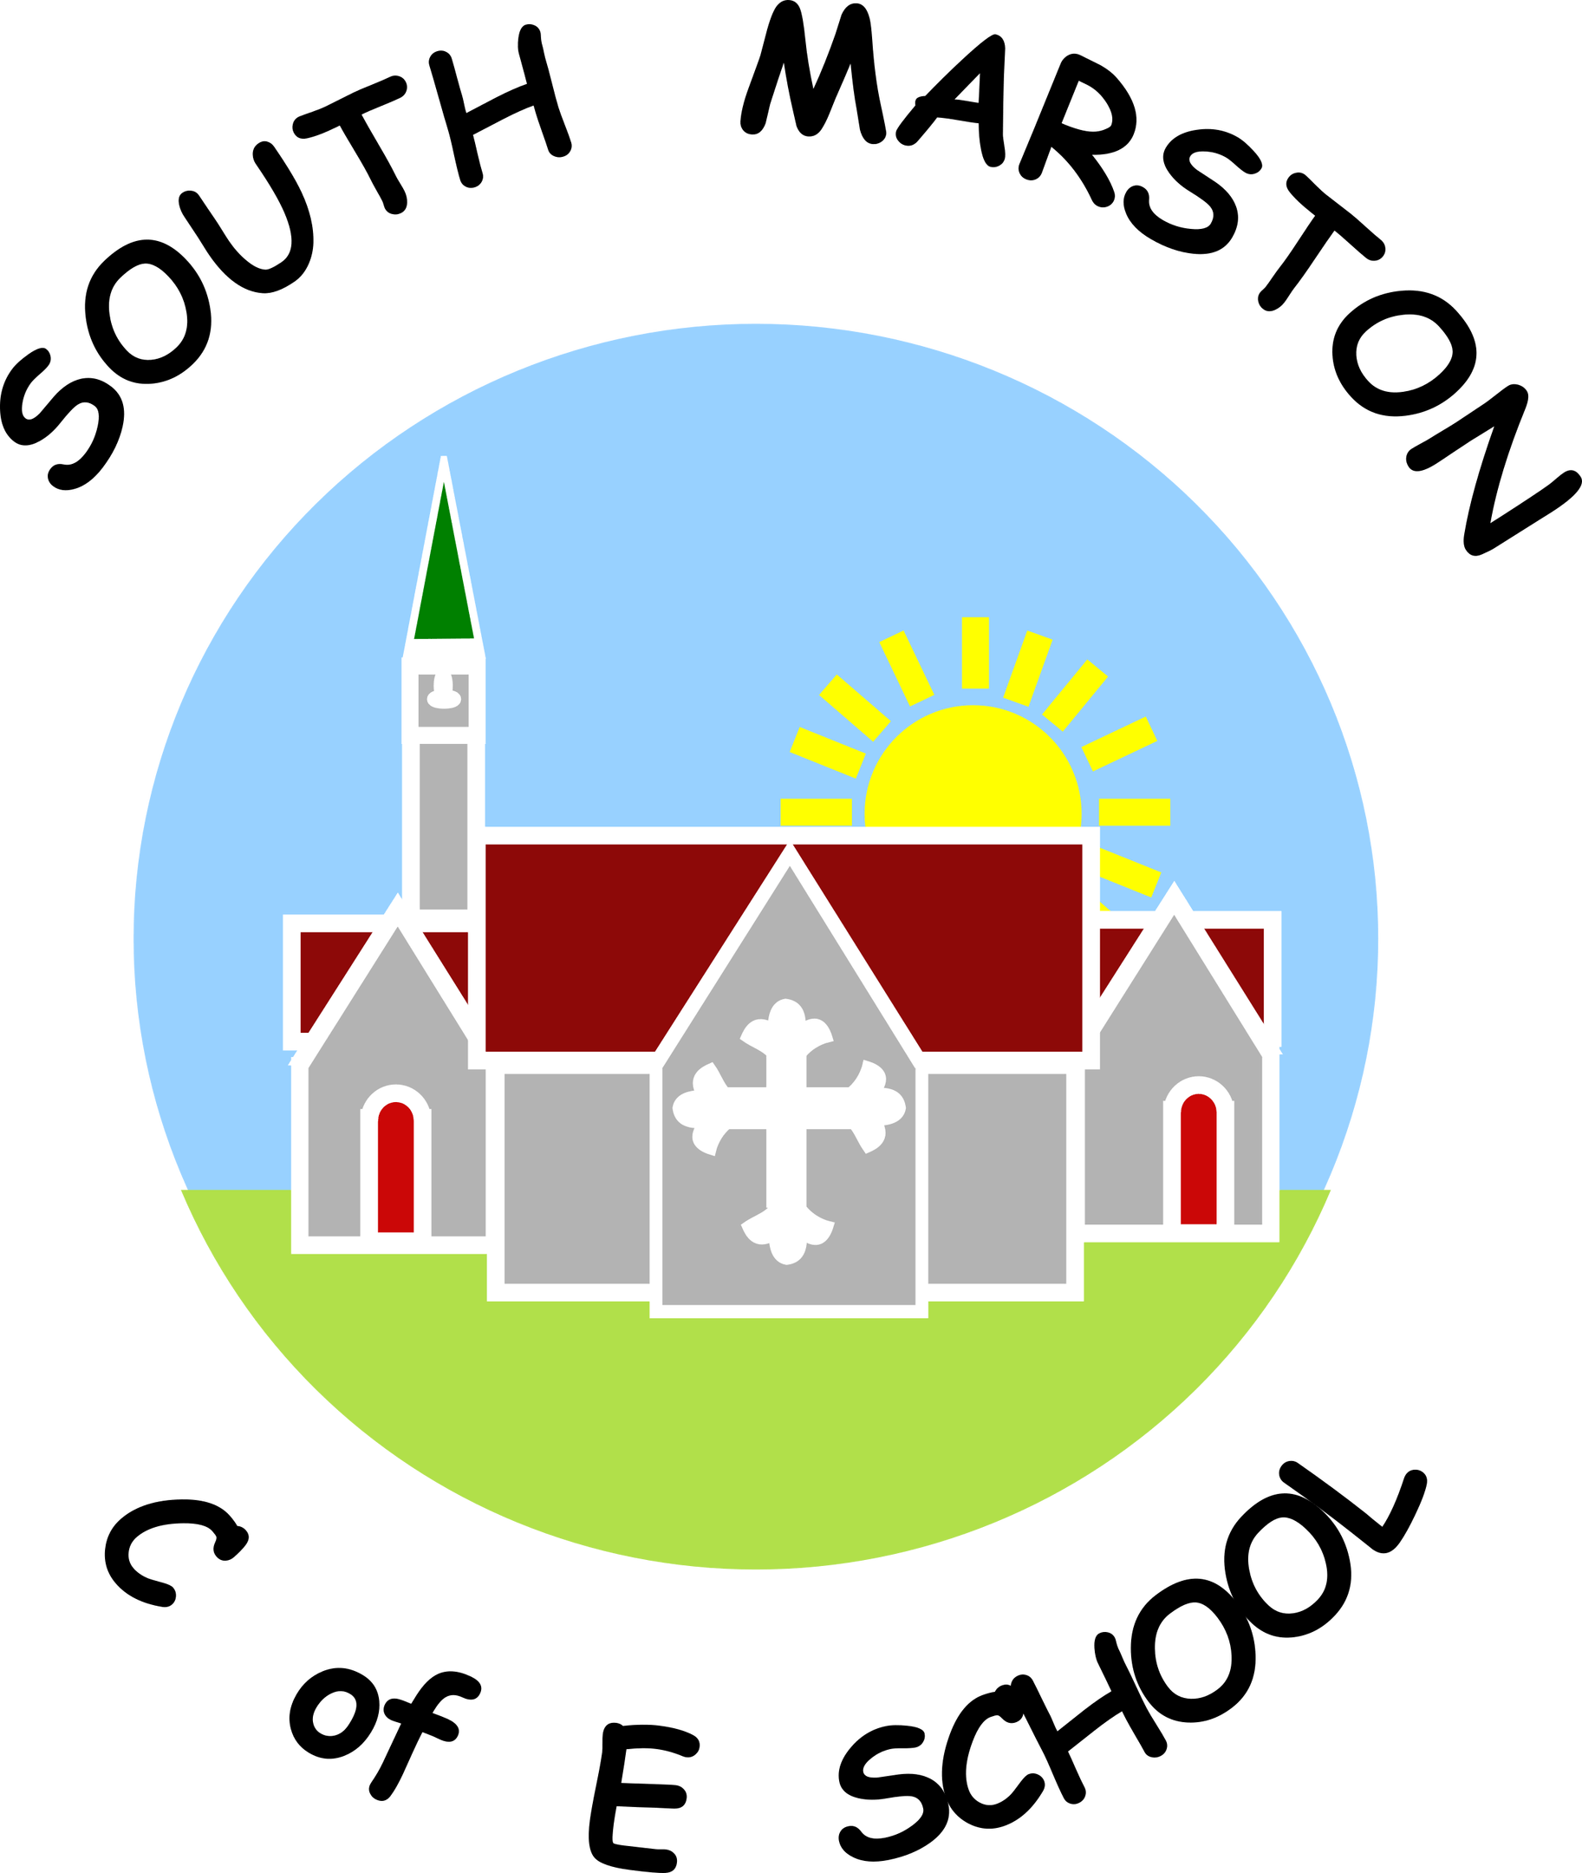

**Art & Design @ South Marston CofE Primary School**

“Art washes away from the soul the dust of everyday life.” Pablo Picasso

**Intent:**

*Why do we teach this? Why do we teach it the way we do?*

At South Marston Primary, we regard Art and Design as integral to providing our pupils with a rich and well-rounded curriculum. We believe that Art and Design offer essential opportunities for children to hone their skills and to explore and express their individual interests, thoughts, and ideas.

Art, craft, and design represent some of the pinnacle of human creativity. We are committed to delivering a high-quality education in these subjects that not only engages and inspires pupils but also challenges them. Our goal is to equip pupils with the knowledge and skills necessary to experiment, innovate, and create their own artistic works. As pupils advance, they should develop critical thinking skills and a deeper understanding of art and design. They should also appreciate how these disciplines both reflect and influence our history, contributing to the culture, creativity, and wealth of our nation.

**The national curriculum for art and design aims to ensure that all pupils:**

1. Produce creative work, exploring their ideas and recording their experiences.
2. Become proficient in drawing, painting, sculpture and other art, craft and design techniques.
3. Evaluate and analyse creative works using the language of art, craft and design.
4. Know about great artists, craft makers and designers, and understand the historical and cultural development of their art forms.

**Implementation:**

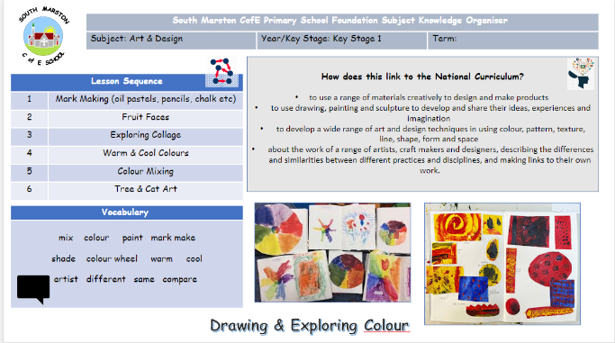*What do we teach? What does this look like?*

At South Marston Primary, the teaching and implementation of the Art and Design Curriculum are aligned with the National Curriculum and, where possible, integrated with other subjects to ensure a cohesive and structured approach.

Throughout the academic year, all pupils engage in Art and Design education. Each year group or class undertakes three main art units, which include topics such as clay sculpture, mosaics, printing, painting, drawing skills, pointillism, and Pop Art. To enrich their learning experience, pupils explore the works of notable local, national, and international artists.

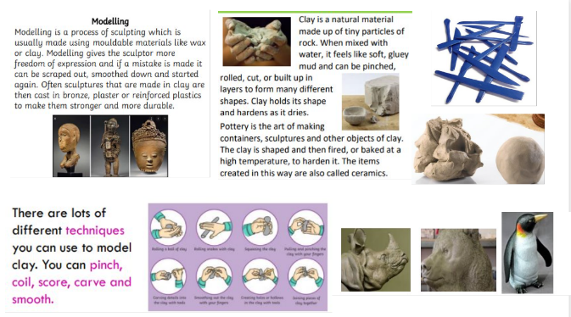We strive to make learning more meaningful by establishing cross-curricular links. For example, pupils might create mosaics while studying Ancient Greece in History, apply their skills to innovative projects in Design and Technology, or design prayer mats in Religious Education.

To ensure comprehensive coverage, skill progression, and support for children’s memory, we provide each child with a knowledge organiser at the beginning of each unit of work. These organisers include key vocabulary, essential content, and relevant images that children can reference and use throughout the unit.

We believe it is crucial for pupils to feel that their artwork is valued and purposeful. To this end, we showcase and display pupils’ art on school walls and washing lines, and share their work through our social media channels and newsletters.

Documentation of pupils’ work is maintained in sketchbooks, project portfolios, and displayed around the school. Additionally, we offer an extracurricular art club and plan enrichment activities to further engage children with art.

Please refer to the Art & Design Curriculum Objectives here: <https://assets.publishing.service.gov.uk/media/5a7ba810ed915d4147621ca0/PRIMARY_national_curriculum_-_Art_and_design.pdf>

As a small school with mixed-age classes, we tailor our teaching to build on each child's prior knowledge effectively. We operate on a two-year cycle (Cycle A and Cycle B) to ensure comprehensive coverage and reinforcement of skills and knowledge.

CYCLE A

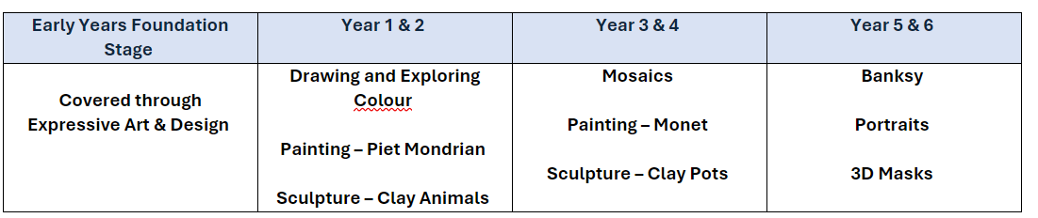

CYCLE B

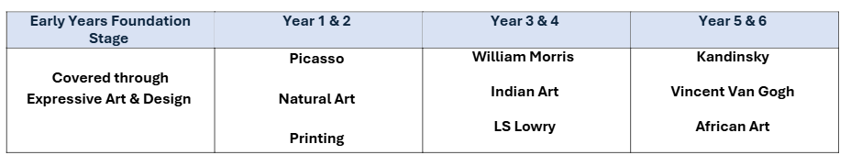

Art and Design are integral parts of the Early Years Foundation Stage (EYFS) curriculum at our school. In the EYFS, children have daily opportunities to explore a diverse range of media and materials, enabling them to create their own artistic works.

Our provision is meticulously planned to align with the children’s interests while fostering the development of essential skills. Through continuous observations, staff gain a deep understanding of each child’s progress and individual needs. This insight allows educators to tailor learning experiences effectively, providing targeted opportunities that support the development of artistic skills. We place significant emphasis on the EYFS, recognising its critical role in laying the foundational skills for all future learning.

**Impact:**

*What will this look like?*

At South Marston, children develop a strong appreciation and enthusiasm for Art and Design through our commitment to recognising and nurturing their talents and artistic abilities. We celebrate and display children’s work, allowing them to express themselves creatively.

By the end of each key stage, we aim for all children to be proficient in drawing, painting, sculpture, and other art, craft, and design techniques. We ensure they can apply and understand the skills, knowledge, and processes taught. Teachers use summative assessments to measure progress and attainment against National Curriculum expectations. In the EYFS, staff use observations and evidence from learning journals to inform future lessons, ensuring that each child is appropriately supported and challenged.

We emphasise critical thinking, encouraging children to evaluate their own and others’ work, understanding how to improve or decide when their work is complete.

The Subject Leader plays a crucial role in monitoring and enhancing the quality of Art and Design teaching and learning. This involves conducting pupil voice sessions, learning walks, and reviewing samples of pupils' work. The Subject Leader also provides updates and professional development for staff, arranges art and design experiences, and oversees the delivery of Art and Design education throughout the school.