

**Design Technology @ South Marston CofE Primary School**

“Design is not just what it looks like and feels like. Design is how it works.” Steve Jobs

**Intent:**

*Why do we teach this? Why do we teach it the way we do?*

At South Marston, our vision for the Design Technology (DT) curriculum is both inspiring and comprehensive, designed to ignite creativity and ensure rigorous, practical learning experiences. Our aim is to empower pupils to use their imagination and problem-solving skills to design and create solutions for real-world challenges. By addressing diverse needs, wants, and values within various contexts, we seek to make the learning process both relevant and engaging.

Our curriculum is meticulously crafted to ensure that all pupils acquire the subject knowledge, skills, and understanding required by the National Curriculum. We emphasise strong cross-curricular links, integrating DT with Mathematics, Science, Computing, and Art. This interdisciplinary approach not only enhances pupils' overall learning experience but also helps them see the connections between different subjects, fostering a more holistic understanding.

Through our Design and Technology program, we are committed to preparing our pupils for future success. By providing them with meaningful opportunities, responsibilities, and hands-on experiences, we aim to equip them with the skills and confidence they need to thrive in later life.

**Implementation:**

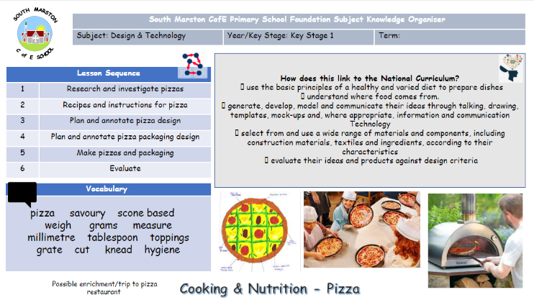*What do we teach? What does this look like?*

Design and Technology is a fundamental component of our school’s educational framework. We are committed to delivering a high-quality Design and Technology curriculum, recognising its essential role in enriching pupils' learning experiences and overall development.

Design and Technology is integral to our educational approach, and we are dedicated to providing a high-quality curriculum that reflects its importance in school life and learning. Our curriculum is designed to offer a broad and balanced range of study, ensuring progression across various units and skills, including food and nutrition, textiles, and structures/mechanisms.

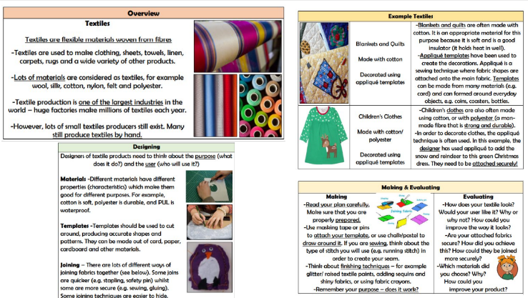Pupils engage with the complete design process—researching, designing, making, and evaluating—through a variety of projects and activities. While we provide a structured framework with specific outcomes and objectives, we also give teachers the flexibility to plan and deliver Design and Technology lessons effectively. Teachers often implement DT as focused blocks of lessons to allow pupils ample time to be critical, inventive, and reflective.

To support skill development and reinforce learning, each child receives a knowledge organiser at the start of each unit. These organisers include key vocabulary, essential content, and relevant imagery, serving as valuable references throughout the unit.

We celebrate pupils' achievements by showcasing their projects and work through newsletters, school displays, and community events.

In the Early Years Foundation Stage, pupils explore various media and materials through both child-initiated and adult-directed activities, linking to early learning goals such as Expressive Art and Design and Understanding the World.

We maintain comprehensive documentation of pupils' work in sketchbooks and project portfolios, which are prominently displayed around the school.

Please refer to the Design Technology Curriculum Objectives here: <https://assets.publishing.service.gov.uk/media/5a7ca43640f0b6629523adc1/PRIMARY_national_curriculum_-_Design_and_technology.pdf>

As a small school with mixed-age classes, we adapt our teaching to build on each child’s prior knowledge effectively, operating on a two-year cycle (Cycle A and Cycle B) to ensure thorough coverage and reinforcement of skills and knowledge.

CYCLE A

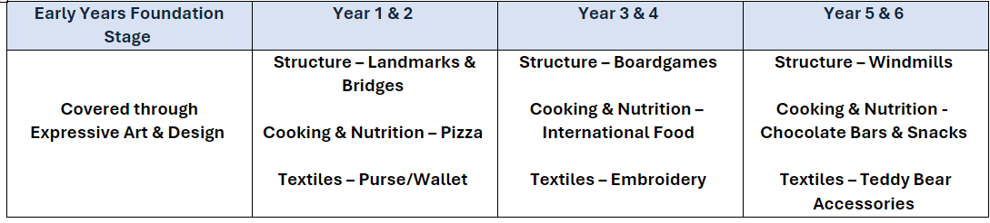

CYCLE B

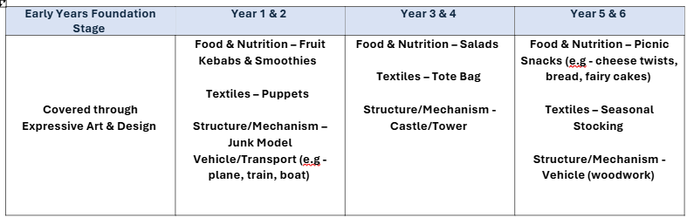

**Impact:**

*What will this look like?*

At South Marston, we ensure that children develop a genuine enjoyment and confidence in Design and Technology, which they can then apply across other areas of the curriculum. Through meticulously planned and executed learning activities, pupils acquire the creative, technical, and practical skills necessary to perform everyday tasks with confidence and engage successfully in an increasingly technological world. This foundation prepares them for further learning and development as they grow.

We assess pupils' skills and knowledge through a variety of methods, including observations, analysis of work in books, and evaluation of final projects. In the Early Years Foundation Stage (EYFS), we monitor progress to determine whether each child is below, at, or above expected attainment levels for their age.

The Subject Leader plays a pivotal role in maintaining and enhancing the quality of Design and Technology education. This includes conducting pupil voice sessions, performing learning walks, and reviewing samples of pupils' work. The Subject Leader also provides staff with updates and professional development, organises experiences, and oversees the implementation of the DT curriculum across the school.

Our goal is for pupils to leave South Marston equipped to contribute actively to their community and nation. We aim to instil a spirit of risk-taking, resourcefulness, innovation, and enterprise through our DT lessons, fostering capabilities that will benefit them throughout their lives.