

**Physical Education @ South Marston CofE Primary School**

"Champions aren't made in the gyms. Champions are made from something they have deep inside them -- a desire, a dream, a vision." Muhammad Ali

**Intent:**

*Why do we teach this? Why do we teach it the way we do?*

Our PE curriculum at South Marston is crafted to provide learners with high-quality teaching and inclusive sporting opportunities that engage all pupils in a supportive and challenging environment. We aim to immerse pupils in a culture that inspires them to embrace physical activity, fostering an enjoyment of PE, encouraging mutual support, and helping each individual achieve their personal best.

Through our programme, pupils gain an understanding of the benefits of sport and exercise, which promotes long-term healthy and active lifestyles. We support pupils in developing resilience and reflection, striving for personal excellence, and demonstrating good sportsmanship.

Our curriculum encourages a positive growth mind-set, instilling the belief that with determination and resilience, anything can be achieved. Pupils learn the value of collaboration, cooperation, and teamwork, along with an appreciation for fairness and equality in play, embedding these lifelong values into their experiences.

Additionally, pupils are given opportunities to compete in a manner that celebrates both their own and others' sporting achievements with maturity.

**Implementation:**

*What do we teach? What does this look like?*

At South Marston, we are committed to promoting physical activity and enhancing the healthy lifestyles of our pupils. We exceed the recommended physical activity levels by incorporating additional PE lessons, outdoor provision, forest school sessions, and a variety of extracurricular clubs. Swimming, dance, and gymnastics are integral to our curriculum, helping to develop fundamental movement skills, hand-eye coordination, balance, strength, and flexibility. We take pride in utilising our own trained staff, who hold additional qualifications in specialised areas like swimming and dance, to lead these sessions.

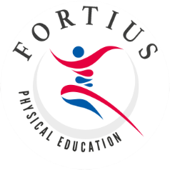Each day, teachers conduct a brief ‘Fit in 5’ session with their class, which may include stretching exercises or activities such as wake and shake or guided dance. Although not statutory, we offer swimming lessons starting from Key Stage 1 as part of our comprehensive PE programme.

Typically, pupils at South Marston receive two hours of teacher-guided PE lessons per week. We believe that PE lessons should be tailored to meet the needs of each class, and therefore, while teachers are encouraged to use the REAL PE scheme for lesson ideas and guidance, they are also empowered to use their professional expertise and judgment. Our curriculum includes both traditional sports, such as football and tennis, and a diverse range of physical activities to ensure breadth and quality in physical education. We are proud to have been recognised for our dedication to PE and healthy living, by achieving the ‘Healthy Schools Award’.

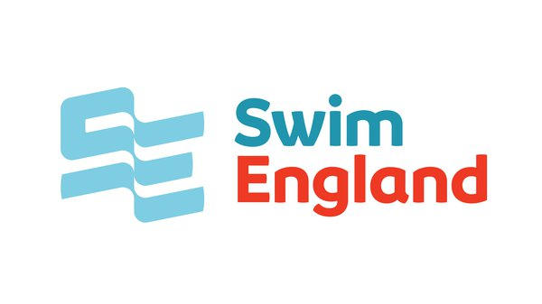All PE lessons start with a warm-up, proceed to the main activity, and conclude with a plenary or cool-down exercise. During lessons, we integrate the REAL PE 'cogs'—creative, physical, social, personal, cognitive, and health and fitness elements.

In addition to our regular curriculum, we offer a variety of extracurricular clubs, including dance, gymnastics, football, athletics, and cross-country. These clubs, led by both school staff and external sports coaches, provide opportunities for students to compete and represent South Marston in various competitions, festivals, and events. We celebrate all pupils' sporting achievements through newsletters, social media, and assemblies.

The PE Lead and Senior Leadership Team are responsible for effectively using Sports Premium funding, which aims to improve health, physical activity, and PE teaching. We allocate this funding towards staff training, such as swimming instruction courses, memberships for PE schemes, support from local PE hubs, specialist projects and events, including guest teacher sessions, and financial assistance for extracurricular activities.

In the Early Years Foundation Stage (EYFS), PE and physical activity are fundamental components of our curriculum. Children in the EYFS are provided with frequent opportunities to enhance their fine and gross motor skills through a variety of games and challenges. These include activities such as climbing on equipment, riding bikes and scooters, and engaging in throwing and catching games. These activities are integrated into both outdoor provision and dedicated PE lessons, supporting the Early Learning Goal of Physical Development.

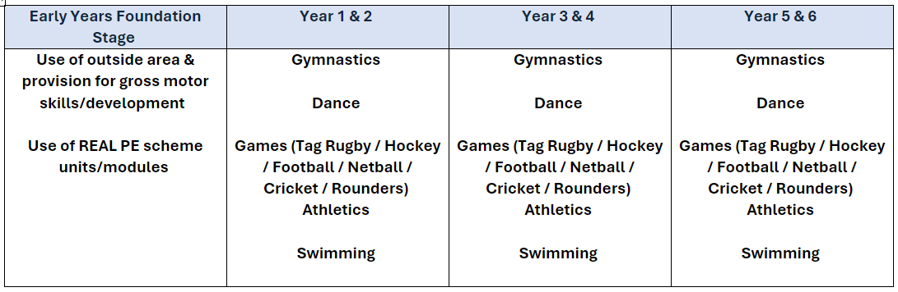

*View the REAL PE scheme here –* [*https://realpe.co.uk/*](https://realpe.co.uk/)

*View Fortius PE here -* [*https://fortiuspe.co.uk/*](https://fortiuspe.co.uk/)

*View the PE National Curriculum objectives here -* [*https://assets.publishing.service.gov.uk/media/5a7c4edfed915d3d0e87b801/PRIMARY_national_curriculum_-_Physical_education.pdf*](https://assets.publishing.service.gov.uk/media/5a7c4edfed915d3d0e87b801/PRIMARY_national_curriculum_-_Physical_education.pdf)

**Impact:**

*What will this look like?*

At South Marston, we inspire children to engage in a wide range of sports through high-quality, engaging, and enjoyable teaching. Our lessons are designed to motivate pupils to take responsibility for their own health and fitness, and many of them thrive in competitive sports. We aim to equip children with the skills and enthusiasm for sport that will foster their development into happy and healthy adults, making use of the knowledge gained through PE.

Pupils learn to take ownership of their health and fitness while experiencing the joy of competitive success. Our goal is to instil a lifelong passion for sport, enabling children to grow into individuals who lead active and fulfilling lives. By encouraging them to become self-directed learners both inside and outside the classroom, we support their growth in sport and beyond. Children are also encouraged to embrace new sports and activities, pushing their limits and persevering through challenges.

The Subject Leader plays a crucial role in monitoring and enhancing the quality of PE and learning. This involves conducting pupil voice sessions, learning walks, and reviewing samples of pupils' work. The Subject Leader also provides updates and professional development for staff, arranges PE experiences, and oversees the delivery of PE education throughout the school.