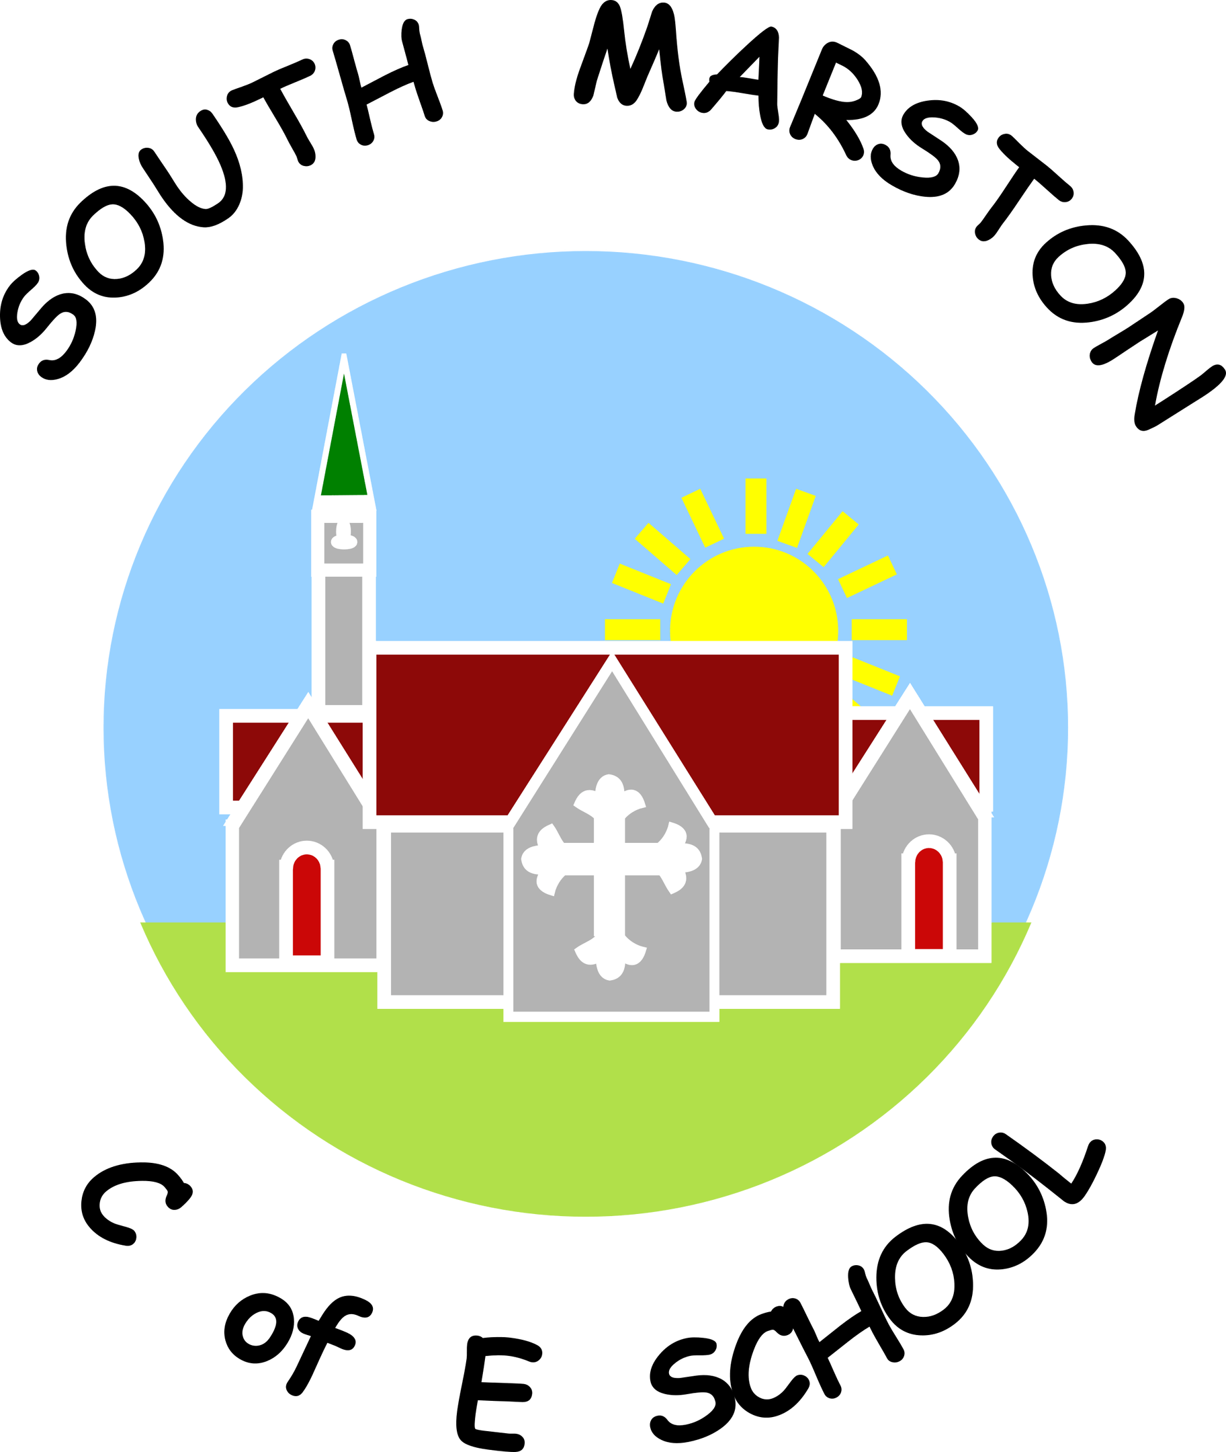

**Religious Education @ South Marston CofE Primary School**

"Faith is unseen but felt, faith is strength when we feel we have none, faith is hope when all seems lost." - Catherine Pulsifer

**Intent:**

*Why do we teach this? Why do we teach it the way we do?*

As a Church of England school, Religious Education (RE) holds a central role in our school life and the broader South Marston community. We are committed to providing all pupils with opportunities to learn from and about various religions to foster a deeper understanding of the world around them. The aim of RE at our school is to help pupils acquire and develop knowledge of Christianity and other major religions represented in Great Britain. We seek to help them appreciate how religious beliefs influence life and behaviour, make reasoned and informed judgments about religious and moral issues, and support their spiritual, moral, social, and cultural development.

Religious Education is integrated throughout the school curriculum, reflecting our values and philosophy through engaging topics such as Justice and Freedom and Heroes/Heroines in Everyday Life. It plays a vital role, alongside other curriculum areas like PSHE, in promoting social awareness and understanding among our pupils. We encourage pupils to question and reflect on the world, their own beliefs, values, and experiences. Our curriculum also incorporates British values, ensuring that pupils are aware of their rights and responsibilities as citizens of the UK.

We aim to nurture creativity, imagination, enquiry, debate, discussion, and independence through our RE curriculum, fostering an environment where pupils can explore and understand diverse perspectives and develop their own viewpoints.

**Implementation:**

*What do we teach? What does this look like?*

In our school, we implement Religious Education (RE) using a variety of agreed schemes, including Understanding Christianity and the Swindon Agreed Syllabus. We approach RE with an inclusive mind-set, respecting the diverse religious backgrounds and beliefs of our pupils and staff. We encourage members of our school community to share their personal experiences and value the connections that can be made between home, school, and faith communities. All religions and their communities are treated with respect and sensitivity.

We recognise the educational value of studying different religions and aim to foster open enquiry and first-hand experiences for both staff and pupils. RE is typically taught on a weekly basis but may also be integrated into class topics or explored through whole-school RE days. Teachers are encouraged to develop key questions related to the syllabus themes and to make interdisciplinary connections where relevant. Lessons are designed to be inclusive, with a variety of teaching methods to ensure all pupils can engage and participate. Interactive and practical activities are used to facilitate discussion and deepen understanding of complex concepts and challenging questions.

We track individual pupils’ progress in RE, though we acknowledge that formal assessments do not capture all aspects of the subject. For instance, pupils’ personal views and ideas, which are central to effective RE, are not subject to formal assessment but are integral to the learning process.

As a Church of England school, we ensure that all pupils participate in a daily act of collective worship and engage in other religious and spiritual experiences, such as visits to our local church, St Mary Magdalene’s, and assemblies led by local clergy.

As a small school with mixed-age classes, we carefully consider each child's existing knowledge to build effectively on their prior learning. To ensure comprehensive coverage of skills, content, and knowledge, we operate a two-year cycle (Cycle A and Cycle B). This approach allows pupils to revisit and consolidate prior learning. Depending on the content and available time, some units may be extended over two terms to provide deeper engagement with the material.

CYCLE A

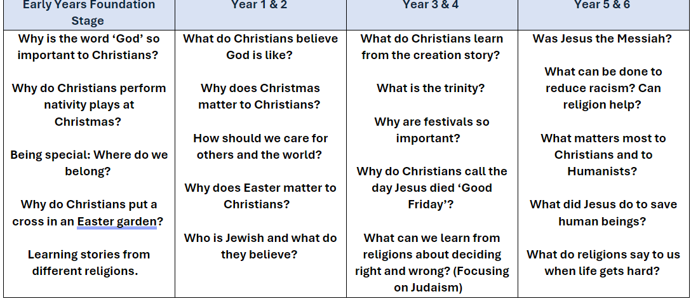

CYCLE B

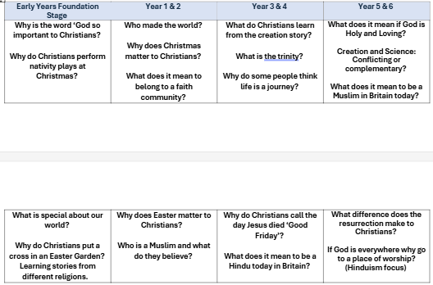

In the Early Years Foundation Stage (EYFS), Religious Education (RE) is integrated into the curriculum through lessons and activities cantered around religious festivals and celebrations, such as Christmas, Easter, and Diwali. These activities, along with introductory questions from our schemes of work, support the children’s Early Learning Goals, particularly in Understanding the World and Personal, Social, and Emotional Development. By exploring these themes, children gain a foundational understanding of various religious traditions while developing key social and emotional skills.

*View the Swindon Agreed RE Syllabus here -* [*https://eschoolscms.blob.core.windows.net/production/schools/61/resource-items/q6E67onFoBje8QjbiqffE0ObV08zw2ItQ5BBRpi1.pdf*](https://eschoolscms.blob.core.windows.net/production/schools/61/resource-items/q6E67onFoBje8QjbiqffE0ObV08zw2ItQ5BBRpi1.pdf)

*View the Understanding Christianity RE scheme here -* [*https://www.understandingchristianity.org.uk/*](https://www.understandingchristianity.org.uk/)

**Impact:**

*What will this look like?*

At South Marston, pupils take great pleasure in learning about various religions and the reasons people may choose to follow or not follow a religion. Through their Religious Education (RE) lessons, pupils make connections between their own lives and the lives of others, both within their community and globally. This fosters an understanding of different cultures and ways of life, making RE a crucial component in our increasingly interconnected world.

RE lessons enable pupils to develop knowledge and understanding of Christianity, other major world religions, and diverse religious traditions and worldviews. They learn to respect different religions, beliefs, values, and ethical life stances by exploring issues within and between faiths. Pupils gain insight into how faith and belief influence individuals, societies, and cultures.

The curriculum also enhances pupils' skills in enquiry and response, including the use of religious vocabulary, questioning, and empathy. They engage in reflection, expression, application, analysis, and evaluation of beliefs, values, and practices, and learn to communicate their personal responses effectively. Additionally, RE provides opportunities for personal reflection and spiritual development, contributing to their overall growth and understanding.

The Subject Leader plays a key role in monitoring and enhancing the quality of teaching and learning in RE. This includes conducting pupil voice sessions, learning walks, and reviewing samples of pupil work. The Subject Leader also provides updates and professional development for the staff team, arranges RE experiences, and reviews the delivery of RE education across the school.