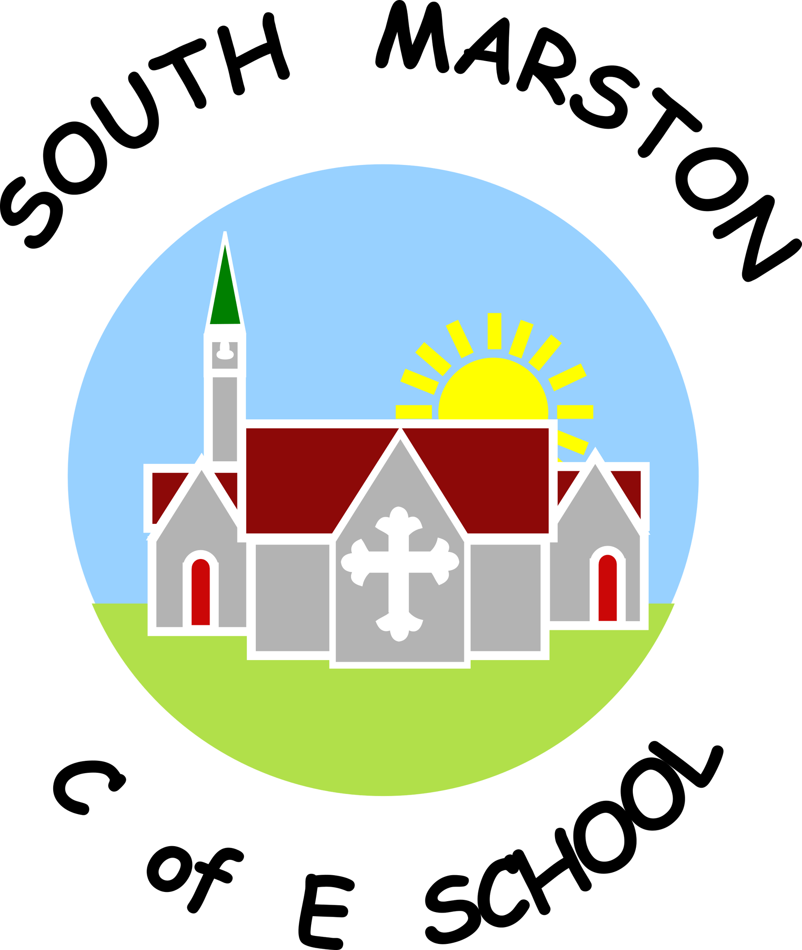
Spanish @ South Marston CofE Primary School
“Language is the road map of a culture. It tells you where its people come from and where they are going.” Rita Mae Brown
Intent:
Why do we teach this? Why do we teach it the way we do?
Our intent is to provide a high-quality Modern Foreign Languages (MFL) education that inspires curiosity, enjoyment and a lifelong interest in learning languages and exploring different cultures. We teach Spanish as our chosen modern foreign language through engaging, practical and interactive lessons sometimes delivered by a visiting trained specialist languages teacher.
We aim for pupils to develop confidence in listening, speaking, reading and writing in Spanish while fostering an appreciation of the rich cultures, traditions and countries of the Spanish-speaking world. By the end of Key Stage 2, pupils will have built a secure foundation in Spanish that prepares them for further language learning in secondary school.
Learning a foreign language broadens pupils' horizons and helps them understand and appreciate different cultures, traditions and ways of life. It develops communication skills, memory, resilience, problem-solving, creativity and confidence, while also strengthening pupils' understanding of English grammar and language structures.
We believe that languages should be experienced beyond discrete lessons. Through our curriculum, pupils develop an appreciation of global cultures and languages by making meaningful links across subjects, helping them become respectful, informed and outward-looking global citizens.

Implementation:
What do we teach? What does this look like?
Spanish is taught throughout Key Stage 2 sometimes by a visiting trained specialist languages teacher using the Twinkl PlanIt Spanish scheme. The carefully sequenced curriculum ensures progression in vocabulary, grammar and language skills, enabling pupils to build confidently on prior learning each year.
Lessons are engaging, interactive and inclusive, providing opportunities for pupils to develop their listening, speaking, reading and writing skills through songs, games, stories, role play, conversations and practical activities. Lessons have clear learning objectives and are designed to build confidence and encourage active participation.
In Year 3, there is a strong emphasis on speaking and listening to establish secure foundations, before gradually developing reading and writing skills as pupils progress through Key Stage 2. Retrieval practice and regular revisiting of previously taught vocabulary help pupils retain knowledge and make meaningful connections between topics.
Languages are celebrated across the wider curriculum and school life. Pupils encounter Spanish and other world languages in a variety of contexts beyond their dedicated lessons, including:
- daily routines such as greetings and the register;
- singing in music lessons and school performances;
- European Day of Languages celebrations;
- learning about countries, traditions and cultures through geography and other curriculum subjects;
- whole-school enrichment activities that promote cultural awareness and appreciation.
These cross-curricular opportunities help pupils understand that language learning is meaningful, enjoyable and relevant to the wider world.
Pupils record their learning in dedicated Spanish books, providing evidence of progression through written work, vocabulary, illustrations, photographs and practical activities. Knowledge organisers support pupils in recalling key vocabulary and language structures throughout each unit. View the Modern Foreign Languages National Curriculum objectives here - https://assets.publishing.service.gov.uk/media/5a7b9246e5274a7318b8f889/PRIMARY_national_curriculum_-_Languages.pdf

Impact:
What will this look like?
What will this look like?
Our Modern Foreign Languages curriculum enables pupils to develop the knowledge, skills and confidence needed to communicate in Spanish while fostering a genuine enthusiasm for language learning.
By the end of Key Stage 2, pupils will be able to understand and respond to spoken and written Spanish using familiar vocabulary and language structures. They will speak with increasing confidence, improving their pronunciation and intonation while communicating their ideas through conversations, questions and simple discussions.
Pupils will write for a range of purposes using the vocabulary and grammatical structures they have learned and will recognise how language reflects culture and identity. Through their learning, pupils develop a greater appreciation of the diversity of the world and the importance of understanding different languages and cultures.
Our curriculum promotes resilience, curiosity and confidence, preparing pupils well for further language study at Key Stage 3 while encouraging a lifelong appreciation of languages and global citizenship.
The Subject Leader monitors the quality of teaching and learning through pupil voice, work scrutiny, learning walks and curriculum review. They work closely with the visiting specialist languages teacher to ensure progression across the school, provide professional development where appropriate, organise enrichment opportunities and continually evaluate the effectiveness of the languages curriculum to ensure the best possible outcomes for all pupils.

