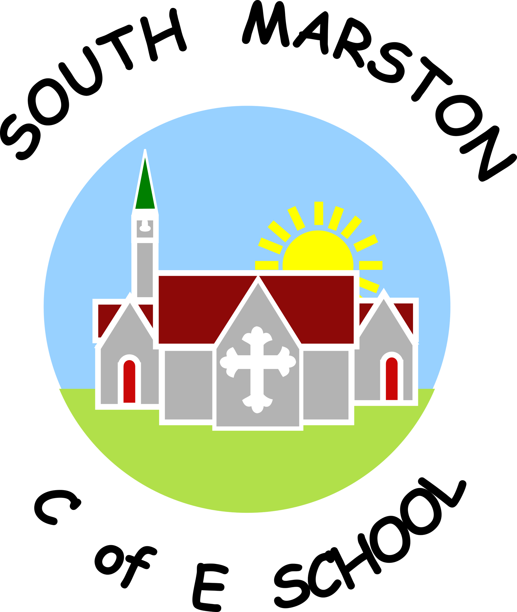
Personal, Social, Health & Economic Education @ South Marston CofE Primary School
“Change is made of choices, and choices are made of character.” Amanda Gorman
Intent:
Why do we teach this? Why do we teach it the way we do?
At South Marston, we recognise that PSHE plays a vital role in supporting children’s personal development, safeguarding and wellbeing. Our curriculum links closely with our Safeguarding, SMSC and British Values aims, helping pupils develop the knowledge, skills and understanding needed to become confident, respectful and responsible members of society.
Our intent is to provide a broad and inclusive PSHE curriculum that equips children with the skills to understand themselves, build positive relationships, make safe choices and contribute positively to their school and wider community. We aim to prepare pupils to become responsible global citizens who understand their rights and responsibilities and appreciate the diverse world in which they live.
We recognise the importance of developing children’s character alongside their academic learning. Through PSHE lessons, assemblies, enrichment opportunities and wider school experiences, pupils develop resilience, empathy, independence, confidence and respect for others.
Our curriculum reflects the needs of our pupils and follows the statutory guidance for Relationships and Health Education. We use updated RSE materials to ensure that teaching is age-appropriate, inclusive and supports children in understanding healthy relationships, respect, boundaries, consent, personal safety and growing up. We value the partnership between school and families and actively encourage parents and carers to play an important role in supporting children’s understanding of these areas.
Our PSHE curriculum follows a clear progression pathway across the school, covering the core themes of health and wellbeing, relationships and living in the wider world. Pupils revisit key concepts regularly, building on their vocabulary, knowledge and understanding as they move through each phase.
We believe that PSHE is central to preparing children for life beyond primary school. Through discussion, reflection and practical experiences, pupils develop the confidence to make informed decisions, manage challenges and contribute positively to society.
Implementation:
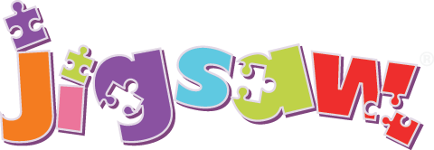
What do we teach? What does this look like?
At South Marston, PSHE is embedded throughout school life through dedicated lessons, assemblies, classroom discussions, enrichment opportunities and everyday interactions. We use the Jigsaw PSHE scheme to support a consistent and progressive approach across the school, while teachers adapt learning to respond to the needs of their pupils and current events.

Our PSHE curriculum covers a wide range of themes including health and wellbeing, relationships, online safety, diversity, citizenship, financial awareness, emotional wellbeing, personal safety and preparing for life in modern Britain. Updated Relationships and Sex Education (RSE) materials support teachers in delivering sensitive and age-appropriate content, ensuring pupils develop the knowledge and understanding needed to form healthy relationships and keep themselves safe. We work closely with parents and carers, recognising their important role in supporting children’s learning and personal development.
Regular PSHE sessions and assemblies provide opportunities for pupils to explore important issues and develop their understanding of the world around them. These include themes such as:
- anti-bullying and kindness;
- online safety and responsible use of technology;
- sun, fire, water and railway safety;
- emotional wellbeing and social skills;
- respect, equality and diversity;
- values and character development;
- citizenship and responsibilities;
- British Values;
- significant historical, cultural and religious events.
Assemblies provide a valuable opportunity for pupils to reflect, discuss and celebrate different experiences, cultures and beliefs, supporting their spiritual, moral, social and cultural development.
We create opportunities for pupils to develop their personal skills through discussion, collaboration and practical experiences. Children are encouraged to express their opinions, listen respectfully to others, resolve disagreements and develop the confidence to contribute positively to school life and the wider community.
Personal development is further enhanced through our Cultural Capital Passport, which identifies the experiences and opportunities we want every child to explore during their time at South Marston. These experiences are designed to broaden children’s horizons, develop character and create memorable learning opportunities. Examples include:
- visiting a theatre;
- taking part in a school trip;
- learning to cook;
- caring for nature and the environment;
- participating in a performance in front of an audience;
- experiencing cultural, sporting and community opportunities.
These experiences help pupils develop confidence, independence, curiosity and an appreciation of the wider world.
We enrich PSHE learning through links with the local community, visitors, fundraising opportunities, national and international events and opportunities for pupils to develop their sense of responsibility and contribution.
We provide opportunities for pupils to develop leadership skills, responsibility and a sense of belonging through a range of pupil-led roles and responsibilities. Children are encouraged to contribute to the life of the school by taking on roles such as school council representatives, eco council members, librarians and classroom monitors. These opportunities enable pupils to develop confidence, communication skills, teamwork and an understanding of how they can make a positive contribution to their school community and the wider world.
The school environment supports PSHE through displays, vocabulary, discussion prompts and shared values. We promote SMSC development and British Values throughout school life, ensuring pupils understand the importance of democracy, respect, tolerance, individual liberty and the rule of law.
In the Early Years Foundation Stage, PSHE is embedded throughout daily provision and links closely with Personal, Social and Emotional Development (PSED). Children develop skills such as managing emotions, forming relationships, showing kindness, understanding rules and becoming increasingly independent through play, routines and carefully planned activities.
Visit the Jigsaw PSHE scheme here - https://jigsawpshe.online/
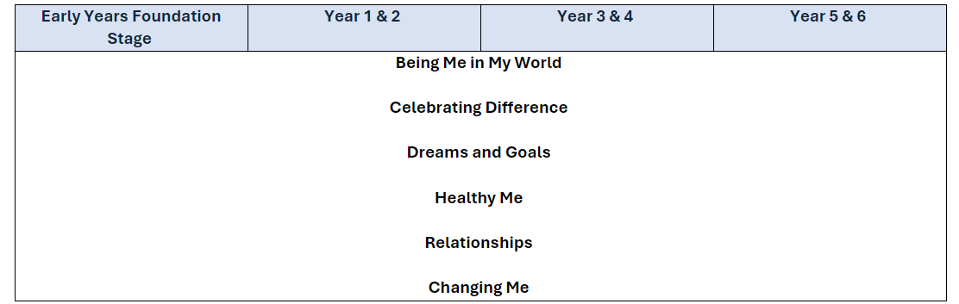
Impact:
What will this look like?
At South Marston, all children develop an understanding of the importance of PSHE, SMSC and British Values and recognise how these influence their lives within school and the wider world. Pupils develop the knowledge, skills and attitudes needed to become confident, respectful and responsible members of society.
Our PSHE curriculum supports pupils in developing resilience, empathy, self-awareness and confidence. Children learn how to build positive relationships, make safe choices, understand their rights and responsibilities and contribute positively to their school and wider community. Through carefully planned learning experiences, pupils develop the personal skills needed to navigate challenges and make informed decisions.
Pupils demonstrate an increasing awareness of personal safety, wellbeing and healthy lifestyles. Through our updated RSE and Health Education curriculum, children develop an age-appropriate understanding of relationships, respect, boundaries, personal safety and how to seek support when needed. We recognise the important partnership between school and families in supporting children’s personal development and wellbeing.
Through regular discussion, reflection and opportunities to explore a range of viewpoints, pupils develop respect for diversity and an appreciation of different cultures, beliefs and experiences. They understand the importance of equality, inclusion, tolerance and British Values, preparing them to participate positively in a diverse society.
The Cultural Capital Passport ensures that all pupils have access to meaningful experiences and opportunities that broaden their horizons and develop their character. Through experiences such as theatre visits, school trips, cooking, caring for nature, performances and community opportunities, children develop confidence, independence, curiosity and a greater understanding of the world around them.
Pupils are encouraged to take an active role in school life and understand the value of their contributions. Through roles such as school council representatives, eco council members, librarians and classroom monitors, children develop leadership skills, confidence, communication and a sense of responsibility. They recognise that their opinions and actions can make a positive difference within their school community.
The impact of PSHE is evident in pupils’ behaviour, attitudes and relationships across the school. Children demonstrate kindness, respect and consideration for others and are increasingly able to reflect on their choices, manage challenges and contribute positively to the wider community.
The Subject Leader plays a key role in monitoring and improving the quality of PSHE teaching and learning. This includes conducting pupil voice sessions, learning walks, reviewing curriculum coverage and evaluating enrichment opportunities. The Subject Leader supports staff development, coordinates personal development experiences and ensures that PSHE remains a central part of children’s education at South Marston.
By the time pupils leave South Marston, they will be healthy, confident, respectful and responsible young people who are prepared for the opportunities, challenges and responsibilities of life beyond primary school.
The Subject Leader plays a vital role in monitoring and improving the quality of PSHE teaching and learning. This role includes conducting pupil voice sessions, performing learning walks, and reviewing samples of pupils' work. The Subject Leader also provides staff with updates and professional development, organises enrichment experiences, and ensures the effective delivery of PSHE education across the school.

