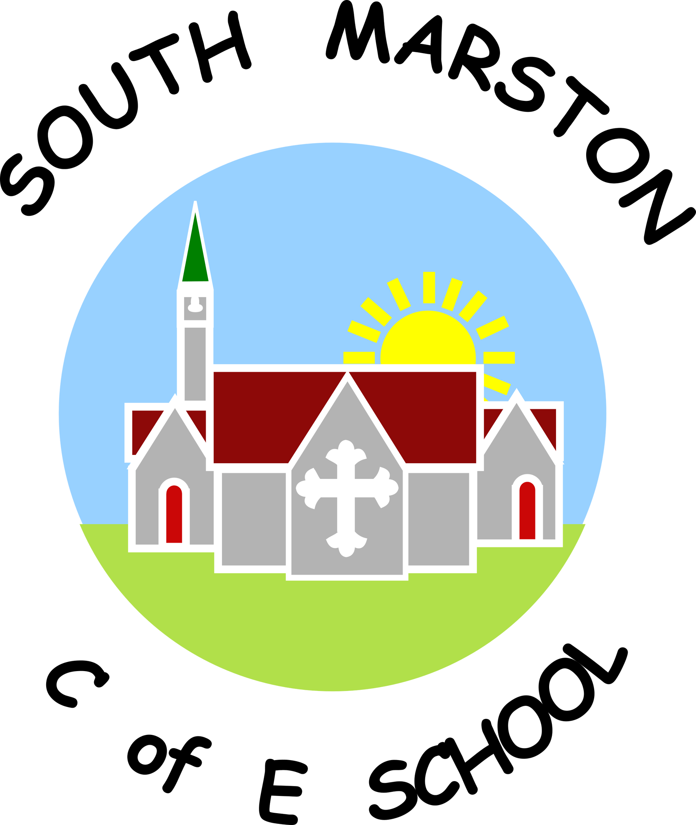

**Personal, Social, Health & Economic Education @ South Marston CofE Primary School**

“Change is made of choices, and choices are made of character.” Amanda Gorman

**Intent:**

*Why do we teach this? Why do we teach it the way we do?*

At South Marston, we recognise that the PSHE curriculum plays a crucial role in supporting the principles of safeguarding and aligns closely with our Safeguarding, SMSC, and British Values policies. We understand the significance of PSHE in helping the school implement the nine protected characteristics outlined in The Equality Act 2010.

Our intent is to develop a PSHE curriculum that enhances learning and equips children with the knowledge and skills necessary to engage with the broader curriculum, collaborate effectively with others, and contribute positively to school life. We aim to prepare pupils to be global citizens in a diverse society, ready for the opportunities, responsibilities, and experiences of later life.

We ensure that the PSHE curriculum reflects the needs of our pupils by building on the statutory content provided in national guidance and implementing the Jigsaw PSHE scheme of work for consistency across the school. Our teaching shows clear progression across all Key Stages within the core themes of health and wellbeing, relationships, and living in the wider world. Each phase builds on the vocabulary, knowledge, and skills from previous stages, allowing pupils to acquire deeper understanding and retain more information.

Teachers are expected to use the PSHE programme to provide pupils with a sound, age-appropriate understanding of risk, enabling them to make safe and informed decisions and recognise the importance of their own mental health and wellbeing. Our curriculum includes age-appropriate Relationship and Sex Education (RSE), in line with statutory guidance, to ensure that all children are safe and capable of developing healthy relationships both now and in their future lives.

**Implementation:**

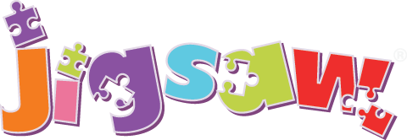*What do we teach? What does this look like?*

At South Marston, we are committed to providing our children with a range of learning opportunities that extend both across and beyond the curriculum. These include specific lessons, circle time, special school projects, and various cultural capital activities designed to enrich pupils’ experiences. Teachers also address PSHE topics as needed when issues arise in their classrooms, ensuring a responsive and relevant approach to the curriculum.

Our school environment supports the PSHE curriculum through the use of questioning, vocabulary, and discussion topics displayed throughout the school. We incorporate Values-Based Learning, British Values, and SMSC displays to enhance pupils' understanding and engagement. Utilising the Jigsaw PSHE scheme, teachers deliver lessons and circle time sessions in a sensitive, nurturing, and progressive manner. Topics such as healthy living, relationships, online safety, diversity, and citizenship are explored comprehensively in these sessions.

We enrich learning through links with the local community, fundraising opportunities, guest visits, and participation in national and international events. PSHE is also a key element of our school assemblies, where we stimulate and challenge children’s spiritual, moral, social, and cultural curiosity.

Personal development is central to our ethos at South Marston. We offer Emotional Literacy support groups and sessions in our dedicated space, ‘The Lavender Lodge’. Additionally, our efforts in promoting healthy eating and physical activity have been recognised with the Healthy Schools Award, celebrating our contributions to pupils' health and wellbeing.

In Upper Key Stage 2, we encourage pupils to take on roles and responsibilities such as serving on the worship council, becoming young leaders, and working as librarians, reinforcing the importance of leadership in lifelong learning.

In the Early Years Foundation Stage, PSHE and citizenship are integral to topic work and are embedded throughout the curriculum. We focus on the Personal, Social, and Emotional Development (PSED) objectives from ‘Development Matters in the EYFS’ and the PSED Early Learning Goals to ensure a comprehensive foundation in these essential areas.

*Visit the Jigsaw PSHE scheme here -* [*https://jigsawpshe.online/*](https://jigsawpshe.online/)

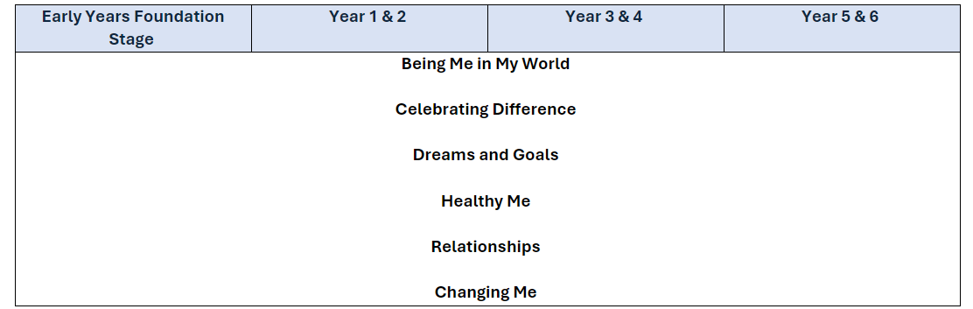

**Impact:**

*What will this look like?*

At South Marston, all children recognise the significance of PSHE, RE, SMSC, and British Values, understanding their impact both within and beyond the school environment.

Our PSHE programme is designed to foster safety, health, self-esteem, resilience, and empathy, addressing barriers to learning and raising aspirations. By doing so, it significantly improves the life chances of vulnerable and disadvantaged pupils. The skills and attributes developed through PSHE education have been shown to enhance academic attainment, attendance rates, employability, and social mobility, particularly among pupils eligible for free school meals.

By the time pupils leave South Marston, our PSHE curriculum ensures they become healthy, independent, and responsible members of society. It supports their personal and social development, addressing many moral, social, and cultural issues associated with growing up. Our curriculum also helps pupils understand their rights and responsibilities and fosters an appreciation for being part of a diverse society. We encourage pupils to develop a sense of self-worth by actively contributing to both school life and the wider community.

The Subject Leader plays a vital role in monitoring and improving the quality of PSHE teaching and learning. This role includes conducting pupil voice sessions, performing learning walks, and reviewing samples of pupils' work. The Subject Leader also provides staff with updates and professional development, organises enrichment experiences, and ensures the effective delivery of PSHE education across the school.