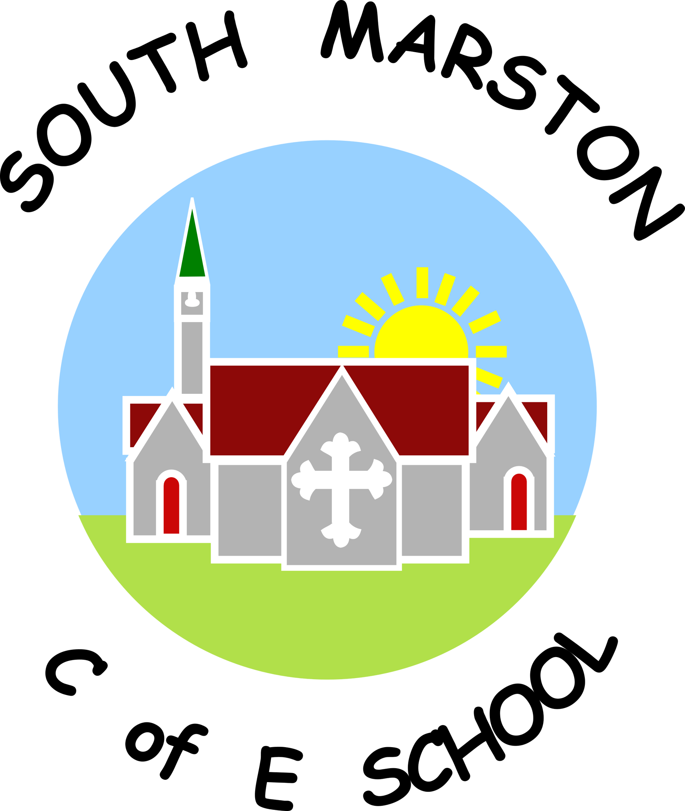

**Music @ South Marston CofE Primary School**

“Music in the soul can be heard by the universe.” Lao Tzu

**Intent:**

*Why do we teach this? Why do we teach it the way we do?*

At South Marston, we view music as a universal language and a profound form of creativity. Our music curriculum is designed to foster a critical engagement with music, guiding pupils to compose, listen discerningly, and appreciate exemplary works within the musical canon, in line with the National Curriculum.

Our aim is to deliver a broad, balanced, and differentiated music education that supports the progressive development of musical concepts, knowledge, and skills. We believe that music is essential for building a sense of community, and as such, we offer all children opportunities to create, perform, and enjoy music both in the classroom and in front of an audience.

Through assemblies and performances, pupils can showcase their talents and demonstrate their ability to perform with consideration for others. Our lessons are structured to help children develop their musical skills, explore a wide range of music, and begin to critically appraise various musical genres.

We strive for our music program to achieve the following objectives: foster a Passion for Music: Cultivate an appreciation for music and inspire a lifelong love for the art form, Enhance Musical Skills: Equip pupils with the skills, knowledge, and confidence to become proficient performers, composers, and listeners, Explore Diverse Genres: Introduce pupils to a variety of musical genres from around the world and across generations, reflecting the multicultural nature of our school and using music to explore and appreciate both British and global cultures, Develop Transferable Skills: Enhance skills such as teamwork, leadership, creative thinking, decision-making, and performance, which are valuable both in and beyond the school setting.

Through our comprehensive music program, we aim to enrich pupils’ learning experiences and contribute to their overall development as well-rounded individuals.

**Implementation:**

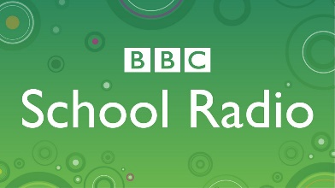*What do we teach? What does this look like?*

At South Marston, our music curriculum adheres to the National Curriculum requirements through the Charanga and BBC Schools scheme of work. While teachers follow this structured scheme, they also have the flexibility to adapt lessons using the ‘freestyle’ component of the package. This allows for integration of thematic learning from other curriculum areas where relevant.

Music instruction is organised into half-termly units with a strong focus on musical vocabulary, enabling pupils to discuss and analyse music using precise terminology. Each lesson integrates various musical strands—performing, listening, composing, the history of music, and the interrelated dimensions of music—to create a rich and progressive learning experience across key stages.

In the Early Years Foundation Stage, music plays a vital role in the learning journey. Rhymes and rhythms are employed to support phonics, handwriting, and mathematics. Children engage with a wide range of songs and rhymes, developing collaborative performance skills and using music to express emotions and reinforce learning.

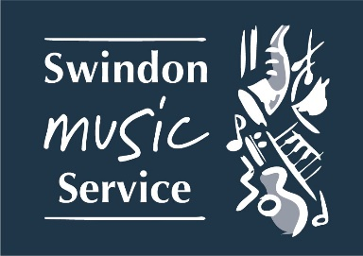In Key Stage 2, pupils benefit from whole-class specialist instruction provided by tutors from the Swindon Music Service. These lessons offer pupils the opportunity to learn to play an instrument within an ensemble, fostering a love for music and further developing their musical skills.

Performance is central to our music education. Pupils participate in a variety of performances throughout their time at South Marston, including nativities, Harvest and Easter performances, Choir and Performing Arts Clubs, weekly singing assemblies, a Summer Concert, voice festivals, and a Leavers’ performance. Confident pupils are encouraged to take part in solo performances. Parents are invited to attend these events, whether held at school or externally. We are committed to embracing music and ensuring this has a place within our school. We ensure guidance and suggestions are implemented through the National Plan for Music.

In addition to our curriculum, pupils can access 1:1 music instruction with peripatetic teachers. We also offer financial support for instrumental lessons to Pupil Premium children to ensure equitable access to music education.

*View the Music National Curriculum objectives here -* [*https://assets.publishing.service.gov.uk/media/5a7b7f8c40f0b645ba3c4b8a/PRIMARY_national_curriculum_-_Music.pdf*](https://assets.publishing.service.gov.uk/media/5a7b7f8c40f0b645ba3c4b8a/PRIMARY_national_curriculum_-_Music.pdf)

*View the Charanga scheme of work here -* [*https://charanga.com/site/*](https://charanga.com/site/)

CYCLE A

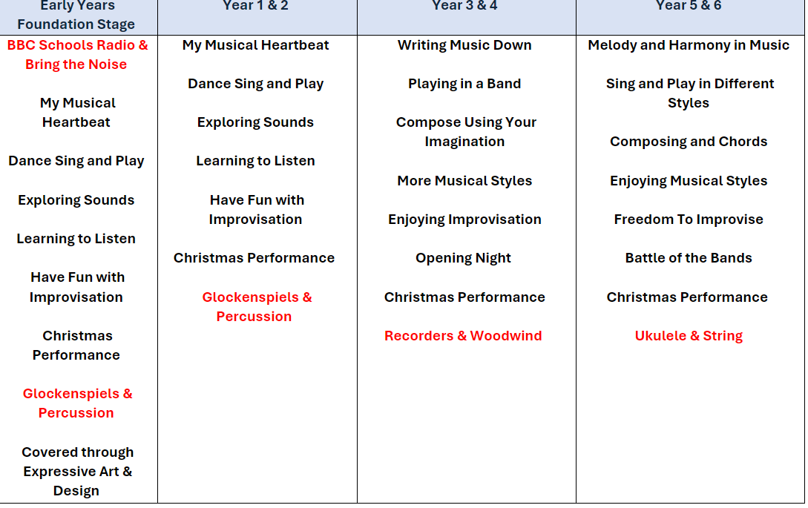

CYCLE B

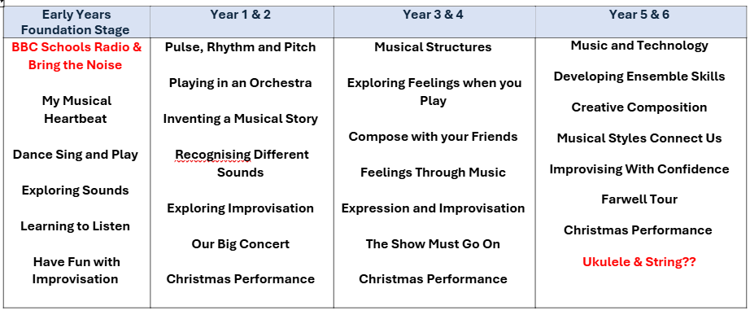

**Impact:**

*What will this look like?*

Our music curriculum at South Marston is meticulously designed to ensure clear progression and the reinforcement of existing skills. We focus on advancing pupils' knowledge and abilities across various musical components, with a strong emphasis on teaching musical vocabulary as an integral part of each unit. Success in acquiring this knowledge and skill indicates that pupils are making good or better progress.

To assess the impact of our curriculum, we employ several methods. We engage with pupils through discussions and interviews to gather their feedback on their learning experiences. Our subject music link governor oversees and monitors the curriculum, ensuring its effectiveness. We also conduct annual reporting and track standards across the curriculum. Additionally, we collect photo and video evidence of pupils' practical learning and use the assessment tools provided by the Charanga scheme. Dedicated time for the music leader is allocated to focus on enhancing curriculum quality. The uptake of after-school music clubs and 1:1 instrumental lessons also serves as a measure of the curriculum's impact.

At South Marston, we are proud of our reputation for high-quality music provision and are committed to celebrating and nurturing pupils' talents and passions within the performing arts sector.

The Subject Leader plays a pivotal role in improving music education. This involves conducting pupil voice sessions, performing learning walks, and reviewing samples of pupils' work. The Subject Leader also provides professional development for staff, organises enriching educational experiences, and ensures the effective implementation of the music curriculum across the school.