

**Computing @ South Marston CofE Primary School**

“The advance of technology is based on making it fit in so that you don't really even notice it, so it's part of everyday life.” Bill Gates

**Intent:**

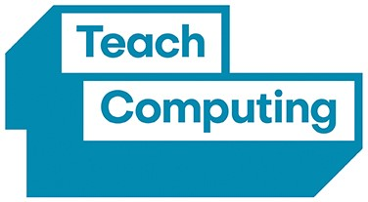*Why do we teach this? Why do we teach it the way we do?*

At South Marston, we recognise the integral role that computers, tablets, and technology play in pupils daily lives at home and school. Our objective is to ensure that pupils leave with not only proficiency in using a variety of devices and applications but also a comprehensive understanding of their underlying principles. As the digital landscape becomes increasingly prominent, we are committed to equipping children with the knowledge and skills to navigate online environments safely and effectively. Furthermore, we aim to foster a strong interest and foundational knowledge in computer science and STEM subjects, preparing them for future academic and professional pursuits.

**Implementation:**

*What do we teach? What does this look like?*

At South Marston, computing is integrated into the curriculum on a regular basis, following the ‘Teach Computing’ scheme developed by the National Centre for Computing Education (NCCE) with support from the Department for Education. This scheme, curated by STEM Learning, the Raspberry Pi Foundation, and BCS, The Chartered Institute for IT, is designed to deliver a world-class computing education to every child in England.

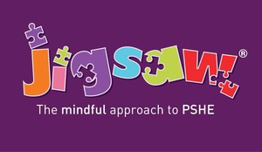The scheme places a strong emphasis on diversity and inclusion, incorporating these values into lesson planning, programmes, and materials. This ensures that pupils are not only inspired but also well-prepared for the future demands of the workplace.

Our computing curriculum aims to build pupils' confidence and proficiency with modern technology through four distinct strands, each with a clear progression of skills:

* Coding and Programming
* Understanding Networks (KS2 only)
* Creative Computing
* Online Safety (also integrated into Jigsaw PSHE teaching)

Online safety is a continuous focus throughout the year, supported by Project Evolve resources and woven into our Jigsaw PSHE curriculum. The curriculum strands are delivered through a combination of dedicated computing lessons and cross-curricular learning opportunities.

To support our computing education, we utilise a range of resources including interactive screens, a class set of laptops, iPads, and Bee Bots. These tools enhance pupils' learning experiences across subjects. For example, pupils might use iPads for research in Geography, Bee Bots for activities related to position and direction in Mathematics, or laptops for editing projects in English. Evidence of pupils' work and projects is maintained in electronic files and class folders.

*For more information, please refer to the following resources:*

Computing Curriculum Objectives - <https://assets.publishing.service.gov.uk/media/5a7c576be5274a1b00423213/PRIMARY_national_curriculum_-_Computing.pdf>

Teach Computing Scheme of Work - <https://teachcomputing.org/>

Project Evolve Scheme of Work - <https://swgfl.org.uk/services/project-evolve/>

Jigsaw PSHE - <https://jigsawpshe.online/>

As a small school with mixed-age classes, we carefully consider each child's existing knowledge to build effectively on their prior learning. To ensure comprehensive coverage of skills, content, and knowledge, we operate a two-year cycle (Cycle A and Cycle B). This approach allows pupils to revisit and consolidate prior learning. Depending on the content and available time, some units may be extended over two terms to provide deeper engagement with the material.

CYCLE A

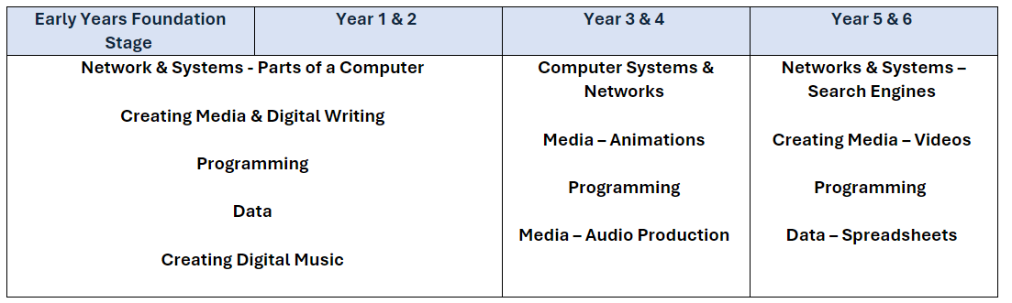

CYCLE B

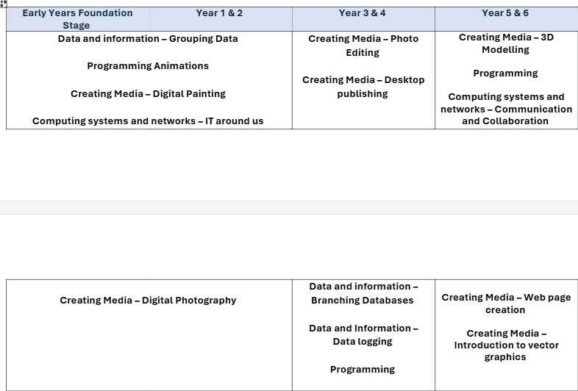

Computing and technology remain crucial components of the Early Years Foundation Stage (EYFS) curriculum. Introducing these subjects helps ensure that children transition into Year 1 with a solid foundational knowledge. While the approach may be less formal compared to older year groups, EYFS children engage in both adult-led and child-initiated activities involving various technological tools, such as Bee Bots, laptops, iPads, interactive screens, stopwatches, and walkie talkies. EYFS staff will integrate technology with the EYFS areas of learning whenever possible. For instance, they might use paint software to create firework pictures, linking to the areas of Expressive Arts & Design and Understanding the World.

**Impact:**

*What will this look like?*

At South Marston Primary, our children value computing because it enables them to achieve in an ever more digitally literate world. Finding the right balance with technology is key to an effective education and a healthy life-style. We feel the way we implement computing helps children realise the need for the right balance and one they can continue to build on in their next stage of education and beyond.

At the end of each learning block focused on a specific strand of our computing curriculum, teachers assess pupils to determine those who have not yet achieved the required skills and knowledge, as well as those who are exceeding age-related expectations. This assessment process includes ongoing tracking using live grids, teacher observations, and discussions. Misconceptions are recognised and addressed if they occur. Learning outcomes and lesson foci are shared with the children at the start and throughout the lesson, reinforcing expectations, encouraging pupils to reflect on their progress and provides teachers with a chance to adapt the lesson accordingly.

The Subject Leader plays a key role in monitoring and enhancing the quality of teaching and learning in computing. This includes conducting pupil voice sessions, learning walks, and reviewing samples of pupil work. The Subject Leader also provides updates and professional development for the staff team, arranges technology-related experiences, and reviews the delivery of computing and online safety education across the school.

By the time pupils leave South Marston, we aim for them to feel confident and secure in their computing and technological skills, understand online safety and security, and be adept at using technology in a constantly evolving world.